Description: C:\Users\LTIT\Documents\download.png

**L&T INSTITUTE OF TECHNOLOGY**

**CENTRALIZED BIOMETRIC ATTENDANCE APP**

DIPLOMA IN COMPUTER ENGINEERING

**(INDUSTRY INTEGRATED)**

SUBMITTED BY

|  |  |
| --- | --- |
| PRATIK PANCHAL | (51412) |
| ARITRO BISWAS | (51561) |
| SHRUTI KALE | (51411) |
| PREETI KURADE | (51413) |

**Under the guidance of**

**Mr. ShashankLale**

**L&T INSTITUTE OF TECHNOLOGY**

Gate No. 2, L&TInfoTech Campus, Mahape,Navi Mumbai – 400 701

(ISO 9001:2008 CERTIFIED

Description: C:\Users\LTIT\Documents\download.png

**L&T INSTITUTE OF TECHNOLOGY**

Gate No. 2, L&TInfoTech Campus, Mahape,Navi Mumbai – 400 701

(ISO 9001:2008 CERTIFIED)

Project Report

On

**CENTRALIZED BIOMETRIC ATTENDANCE APP**

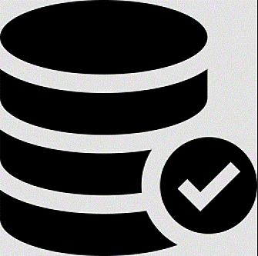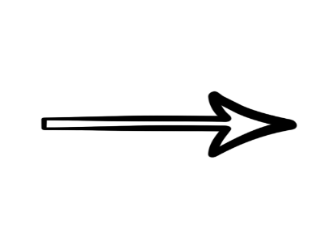

SUBMITTED BY

|  |  |
| --- | --- |
| PRATIK PANCHAL | (51412) |
| ARITRO BISWAS | (51561) |
| SHRUTI KALE | (51411) |
| PREETI KURADE | (51413) |

DIPLOMA IN COMPUTER ENGINEERING

**(INDUSTRY INTEGRATED)**

**Under the guidance of**

**Mr. ShashankLale**

Description: C:\Users\LTIT\Documents\download.png

**L&T INSTITUTE OF TECHNOLOGY**

Gate No. 2, L&TInfoTech Campus, Mahape,Navi Mumbai – 400 701

(ISO 9001:2008 CERTIFIED)

**CERTIFICATE**

The group project titled

**“CENTRALIZED BIOMETRIC ATTENDANCE APP”**,

Was carried out by the following students,

|  |  |  |
| --- | --- | --- |
| **NAME** | **ROLL NO** | **EXAM SEAT NO** |
| PRATIK PANCHAL | 51412 | 129076 |
| ARITRO BISWAS | 51561 | 129101 |
| SHRUTI KALE | 51411 | 129077 |
| PREETI KURADE | 51413 | 129082 |

In Semester VII and has been examined for Diploma in Computer Engineering (Industry Integrated) by **Maharashtra State Board of Technical Education (MSBTE).**

**Date of Exam: _________________**

|  |  |  |
| --- | --- | --- |
| **_________________** | **_________________** | **_________________** |
| **Project Guide** | **External Examiner** | **Principal** |

**ACKNOWLEDGEMENT**

No Project is ever complete without the guideline of those expert who have already traded this past before and hence become master of it. We would like to take this opportunity to take all those individuals who have helped in visualizing this project.

We are grateful to our principal **MR. B.A.DAMAHE** for providing us with an environment to complete our project successfully.

We would like to express our sincere thanks to our **H.O.D.MRS. ASAVARI SHIPOSKAR** for giving us valuable guidance.

We would like to thank **MR. SHASHANK LALE** who was also our project guide for giving us valuable guidance and timely suggestion.

Last but not least we would like to thank all the members of Computer Engineering Department who helped us directly or indirectly in completing our project.

**CENTRALIZED BIOMETRIC ATTENDANCE APP.**

**CERTIFICATE**

Date - _________________

This is to certify that the following students have completed Industrial Project **“CENTRALIZED BIOMETRIC ATTENDANCE APP”**

For **L&T PUBLIC CHARITABLE TRUST**.

|  |  |  |
| --- | --- | --- |
| NAME | BRANCH / SEM | ROLLNO |
| ARITRO BISWAS | CD  - VII | 51561 |
| PRATIK PANCHAL | 51412 |
| SHRUTI KALE | 51411 |
| PREETI KURADE | 51413 |

Project Duration - Jun 2017 to Sept. 2017

Project Supervisor cum Guide: ___________________

This mobile App has been developed in Android ADT. It is tested for Centralized Biometric Employee Attendance of LTPCT Centers.

Sincerely,

|  |  |
| --- | --- |
|  | ________________(Signature) |
|  | ________________(Name) |
| Company Seal: | ________________(Designation) |

.

|  |  |  |
| --- | --- | --- |
| **Sr No.** | **Content** | **Page No.** |
| **1** | **Introduction** | **1-2** |
| **2** | **Technology Stack** | **3-24** |
|  | PHP | 4 |
|  | Android app development in JAVA | 7 |
|  | MySQL | 10 |
|  | HTML | 13 |
|  | CSS | 15 |
|  | jQuery | 17 |
|  | External APIs used | 19-20 |
|  | * + Adafruit for arduino | 19 |
|  | * + USB Serial for communication with arduino | 19 |
|  | * + Bootstrap for GUI designing | 20 |
|  | Hardware Used | 21-22 |
|  | * + Arduino UNO | 21 |
|  | * + R305 biometric module | 22 |
| **3** | **Problem Identification Objectives** | **25-27** |
| **4** | **Literature Survey** | **28-29** |
| **5** | **Methodologies** | **30-47** |
|  | Method Used- Iterative Model | 31 |
|  | Design Model | 35 |
|  | Business Process Model | 36 |
|  | ER Diagram | 37 |
|  | DFD | 38 |
|  | Flow Charts | 40-47 |
|  | * + Arduino UNO | 40 |
|  | * + Android Application | 41 |
|  | * + Attendance Reporting | 45 |
| **6** | **Result Analysis and Implementation** | **48-68** |
|  | Challenges Faced and Solutions | 49-55 |
|  | * + Password Security | 49 |
|  | * + Loss less communication with arduino and android | 53 |
|  | Screen shots | 56 |
| **7** | **Conclusion** | **69-70** |
| **8** | **Scope of project** | **71-72** |
| **9** | **Limitations** | **73-74** |
| **10** | **References** | **75-76** |

**LIST OF FIGURES**

|  |  |  |
| --- | --- | --- |
| **Sr.no.** | **Figure Name** | **Page No.** |
| 1.1 | Actual Implementation | 2 |
| 2.1 | PHP Cross Platform | 5 |
| 2.2 | PHP Development | 6 |
| 2.3 | PHP Structure | 6 |
| 2.4 | Android App Development | 7 |
| 2.5 | MySQL Symbol | 10 |
| 2.6 | HTML Structure | 13 |
| 2.7 | HTML To CSS | 16 |
| 2.8 | jQuery Symbol | 17 |
| 2.9 | jQuery Requirements | 18 |
| 2.10 | Arduino UNO | 21 |
| 2.11 | R305 Module | 23 |
| 4.1 | Biometric Usages in 2016 | 29 |
| 5.1 | Iterative Model Process | 31 |
| 5.2 | Design Model | 35 |
| 5.3 | Business Process Model | 36 |
| 5.4 | ER Diagram | 37 |
| 5.5 | Data Flow Diagram | 38 |
| 5.6 | Arduino UNO Flow Chart | 40 |
| 5.7 | Android App Flow Chart | 41 |
| 5.8 | Biometric Reporting Flow Chart | 45 |
| 6.1 | Password Verification | 49 |
| 6.2 | Registering New Admin Password | 50 |
| 6.3 | Generating Hash Value | 51 |
| 6.4 | Integrity Checking | 52 |
| 6.5 | Android App SS | 56 |
| 6.6 | Biometric Attendance Report SS | 63 |

**LIST OF TABLES**

|  |  |  |
| --- | --- | --- |
| **Table no.** | **Table Name** | **Page No.** |
| 2.1 | Specifications of PHP | 4 |
| 2.2 | Specifications of Arduino | 22 |
| 2.3 | Specifications of R305 | 23 |
| 6.1 | Arduino Communication messages | 53 |

**LIST OF ABBREVIATIONS**

|  |  |  |
| --- | --- | --- |
| **Sr No** | **Abbreviations** | **Full Forms** |
| 1 | PHP | Hypertext Preprocessor |
| 2 | HTML | Hypertext Markup Language |
| 3 | XML | Full Extensible Markup Language |
| 4 | AP.NET | Active Server Pages |
| 5 | OS | Operating Systems |
| 6 | GUI | Graphical User Interface |
| 7 | RDBMS | Relational Database Management System |
| 8 | SDK | Software Development Kit |
| 9 | UX | User Experience |
| 10 | UI | User Interface |
| 11 | SDLC | Software Development Life Cycle |
| 12 | QA | Quality Assurance |
| 13 | IDE | Integrated Development Environment |
| 14 | CSS | Cascading Style Sheets |
| 15 | [SVG](https://en.wikipedia.org/wiki/Scalable_Vector_Graphics) | Scalable Vector Graphics |
| 16 | AJAX | Asynchronous JavaScript And XML |
| 17 | DOM | Document Object Mode |
| 18 | JSON | JavaScript Object Notation |
| 19 | RFID | Radio Frequency Identification |
| 20 | NFC | Near Field Communication |
| 21 | API | Application Programming Interface |
| 22 | USB | Universal Serial Bus |
| 23 | CDC | Connected Device Configuration |
| 24 | UART | Universal Asynchronous Receiver-Transmitter |
| 25 | DPI | Dots Per Inch |
| 26 | ER | Entity Relation |
| 27 | DFD | Data Flow Diagram |
| 28 | BPM | Business Process Model |
| 29 | SS | Screen Shots |
| 30 | OTP | One Time Password |

**ABSTRACT**

Fingerprint verification is one of the most reliable personal identification methods in biometrics. In this project online biometrics attendance system is designed and implemented.

This online based biometrics and serial port communication technique using android device solves the problem of spurious attendance and trouble of maintaining attendance for multiple departments. It can make the user’s attendances more easy and effective.

In online biometric attendance system project, fingers are the main focus because of their characteristics that vary from person to person. This means that two people cannot have identical finger marks whatsoever.

In the analysis of fingerprint attendance system project, the machine compares several patterns of fingers along with their constructions and properties of human skins.

**Chapter 1**

**INTRODUCTION**

**INTRODUCTION**

Many institutes are trying to identify accurate, safe and reliable techniques to protect access rights to their existing services or operation. Biometrics, especially in information technology, encompasses methods to analyse physical and behavioural identities to extract unique features for identification or monitoring purposes. Various physical features including faces, eyes, fingers, hands, veins, etc. can be used by this technology

A fingerprint-based Attendance Management System is developed to provide a faster, more secure, and more convenient method of user verification than passwords and tokens can provide for a reliable personal identification.

This project uses an android application and a fingerprint module to communicate with user. User marks attendance on the fingerprint module and the fingerprint module then receives the fingerprint of the user and converts it to an image, and an identification (id) number is given to that image. Which is received by the android application and with the help of fingerprint id the user details/data is received by the application from database.

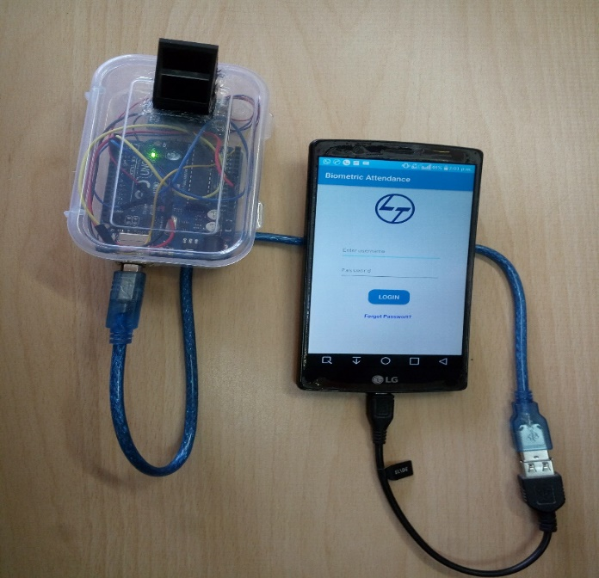

**Fig 1.1: Actual Implementation**

**Chapter 2**

**TECHNOLOGY STACK**

**TECHNOLOGY STACK**

**PHP**

**What is PHP?**

Hypertext Pre-processor (earlier called, Personal Home Page) PHP is an HTML-embedded, server-side scripting language designed for web development. It is also used as a general purpose programming language. It was created by RasmusLerdorf in 1994 and appeared in the market in 1995.

PHP is a [server-side scripting](https://en.wikipedia.org/wiki/Server-side_scripting) language designed primarily for [web development](https://en.wikipedia.org/wiki/Web_development) but is also used as a [general-purpose programming language](https://en.wikipedia.org/wiki/General-purpose_programming_language).

PHP-“personal homepage” provides an integration of general purpose programming and web-development scripting language. It is suited for server-side web development, scripting and used by large sectors of professional web sites.

PHP can be used to develop dynamic web pages- server side scripting. The world famous social networking website Facebook is scripted in PHP. It can be used to develop the dynamic web applications and create gateways for security and financial transactions.

PHP compiler is a freeware software by PHP group. It gives the output in HTML, XML, etc.. It is similar to Microsoft’s ASP.NET, Sun Microsystems-Java server pages.

|  |  |
| --- | --- |
| **Designed by** | RasmusLerdorf |
| **Developer** | Zend Technologies |
| **OS** | Unix like, Windows |
| **License** | PHP License (most of Zend Engine under Zend Engine License) |
| **Filename Extensions** | .php, .phtml,.php3,.php4, .php5,.php7,.phps |
| **Website** | php.net |

**Table 2.1: Specifications of PHP**

"PHP is a server-side, cross-platform, HTML embedded scripting language." That's a mouthful, but if we break the definition down into smaller pieces, it is easier to understand.

**Server-Side:** This means that PHP scripts execute on the Web server, not within the browser on your local machine.

**Cross-Platform:** Cross-platform means that PHP scripts can run on many different operating systems and Web servers. PHP is available for the two most popular Web server configurations (IIS running on Windows NT and Apache running on UNIX).

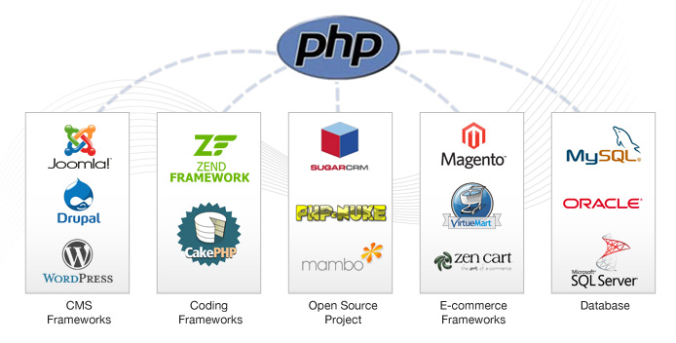

**Fig 2.1: PHP Cross Platform**

**PHP Development**

PHP is strong tool for create dynamic and interactive Web pages. PHP is the widely-used, free, and efficient for rich applications/website development. This is open source technology, runs on Apache web server which in turn runs seamlessly on Windows, Linux, Solaris, and various other UNIX platforms. Sun core Microsystems’s PHP development services offers unique, dynamic and highly functional web applications for across the world. We have complete experience in providing solutions to companies ranging from small websites to more complex/large websites. Our team of experts always follows well-defined development methodology and applies quality standards with each website.

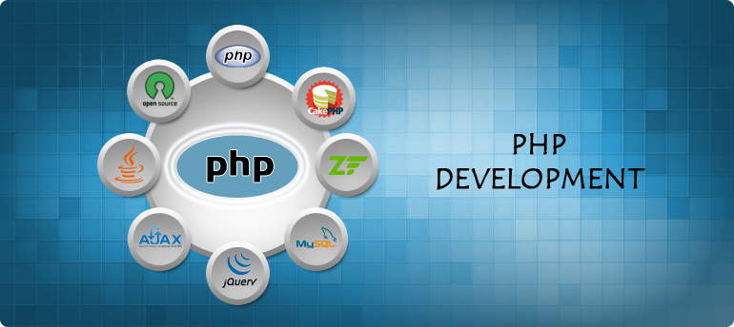

**Fig 2.2: PHP Development**

**Use**

PHP is a general-purpose scripting language that is especially suited to [server-side](https://en.wikipedia.org/wiki/Server-side_scripting) [web development](https://en.wikipedia.org/wiki/Web_development), in which case PHP generally runs on a [web server](https://en.wikipedia.org/wiki/Web_server). Any PHP code in a requested file is [executed](https://en.wikipedia.org/wiki/Execution_(computing)) by the PHP runtime, usually to created[dynamic web page](https://en.wikipedia.org/wiki/Dynamic_web_page) content or dynamic images used on websites or elsewhere. It can also be used for [command-line](https://en.wikipedia.org/wiki/Command-line) scripting and [client-side](https://en.wikipedia.org/wiki/Client-side) [graphical user interface](https://en.wikipedia.org/wiki/Graphical_user_interface) (GUI) applications. PHP can be deployed on most web servers, many [operating systems](https://en.wikipedia.org/wiki/Operating_system) and [platforms](https://en.wikipedia.org/wiki/Computing_platform), and can be used with many [relational database management systems](https://en.wikipedia.org/wiki/Relational_database_management_system) (RDBMS). Most [web hosting](https://en.wikipedia.org/wiki/Web_hosting) providers support PHP for use by their clients. It is available free of charge, and the PHP Group provides the complete source code for users to build, customize and extend for their own use.

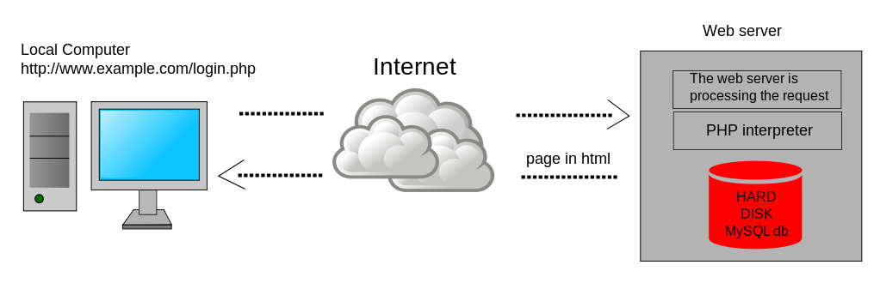

**Fig 2.3: PHP Structure**

**ANDROID APP DEVELOPMENT IN JAVA**

Android software development is the process by which new applications are created for the Android devices operating system. Applications are usually developed in Java programming language using the Android software development kit (SDK), but other development environments are also available.

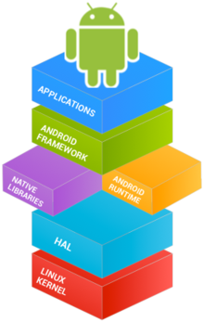

**Fig 2.4: Android App development**

The process of software development is called the **Software Development Lifecycle (SDLC).**

The lifecycle of mobile development is largely no different than the SDLC for web or desktop applications. As with those, there are usually 5 major portions of the process:

1. **Inception** – All apps start with an idea. That idea is usually refined into a solid basis for an application.
2. **Design** – The design phase consists of defining the app’s User Experience (UX) such as what the general layout is, how it works, etc., as well as turning that UX into a proper User Interface (UI) design, usually with the help of a graphic designer.
3. **Development** – Usually the most resource intensive phase, this is the actual building of the application.
4. **Stabilization** – When development is far enough along, QA usually begins to test the application and bugs are fixed. Often times an application will go into a limited beta phase in which a wider user audience is given a chance to use it and provide feedback and inform changes.
5. **Deployment**- Often many of these pieces are overlapped, for example, it’s common for development to be going on while the UI is being finalized, and it may even inform the UI design. Additionally, an application may be going into a stabilization phase at the same that new features are being added to a new version.

Furthermore, these phases can be used in any number of SDLC methodologies such as Agile, Spiral, Waterfall, etc.

**What is Java?**

Android applications are developed using the Java language. As of now, that’s really your only option for native applications. Java is a very popular programming language developed by Sun Microsystems (now owned by Oracle). Developed long after C and C++, Java incorporates many of the powerful features of those powerful languages while addressing some of their drawbacks. Still, programming languages are only as powerful as their libraries. These libraries exist to help developers build applications.

Some of the Java’s important core features are:

* It’s easy to learn and understand
* It’s designed to be platform-independent and secure, using virtual machines
* It’s object-oriented

Android relies heavily on these Java fundamentals. The Android SDK includes many standard Java libraries (data structure libraries, math libraries, graphics libraries, networking libraries and everything else you could want) as well as special Android libraries that will help you develop awesome Android applications.

**Android SDK-**

The Android software development kit (SDK) includes a comprehensive set of development tools. These include a debugger, libraries, a handset emulator based on QEMU, documentation, sample code, and tutorials.

To develop Android applications (or any Java applications, for that matter), you need a development environment to write and build applications. Eclipse is a very popular development environment (IDE) for Java and the preferred IDE for Android development.

**Compiling Code**

The developer, need to compile your Android projects and package them up to deploy onto devices. The Eclipse development environment (used with the Android Development plug-in) makes this pretty painless. In Eclipse, automatic compilation is often turned on by default. This means that every time you save a project file, Eclipse recompiles the changes for your application package. You immediately see compile errors. Eclipse also interprets Java as you type, providing handy code coloring and formatting as well as showing many types of errors as you go. Often, you can click on the error and have Eclipse automatically fix a typo, or add an import statement, or provide a method stub for you, saving lots of typing.

The build process, for regular Java projects, results in a file with the extension of JAR – Java ARchive. Android applications take JAR files and package them for deployment on devices as Android PacKage files with an extension .apk. These formats not only include your compiled Java code, but also any other resources, such as strings, images, or sound files, that your application requires to run as well as the Application Manifest file, AndroidManifest.xml.

**MYSQL**

MySQL is the most popular Open Source Relational SQL Database Management System. MySQL is one of the best RDBMS being used for developing various web-based software applications.



**Fig 2.5: MySQL Symbol**

**What is a Database?**

A database is a separate application that stores a collection of data. Each database has one or more distinct APIs for creating, accessing, managing, searching and replicating the data it holds.

Other kinds of data stores can also be used, such as files on the file system or large hash tables in memory but data fetching and writing would not be so fast and easy with those type of systems.

Nowadays, we use relational database management systems (RDBMS) to store and manage huge volume of data. This is called relational database because all the data is stored into different tables and relations are established using primary keys or other keys known as Foreign Keys.

**MySQL Database**

MySQL is a fast, easy-to-use RDBMS being used for many small and big businesses.

MySQL is developed, marketed and supported by MySQL AB, which is a Swedish company.

MySQL is becoming so popular because of many good reasons −

* MySQL is released under an open-source license. So you have nothing to pay to use it.
* MySQL is a very powerful program in its own right. It handles a large subset of the functionality of the most expensive and powerful database packages.
* MySQL uses a standard form of the well-known SQL data language.
* MySQL works on many operating systems and with many languages including PHP, PERL, C, C++, JAVA, etc.
* MySQL works very quickly and works well even with large data sets.
* MySQL is very friendly to PHP, the most appreciated language for web development.
* MySQL supports large databases, up to 50 million rows or more in a table. The default file size limit for a table is 4GB, but you can increase this (if your operating system can handle it) to a theoretical limit of 8 million terabytes (TB).
* MySQL is customizable. The open-source GPL license allows programmers to modify the MySQL software to fit their own specific environments.

**Administrative MySQL Command**

Here is the list of the important MySQL commands, which you will use time to time to work with MySQL database −

1. USE Databasename − This will be used to select a database in the MySQL workarea.
2. SHOW DATABASES − Lists out the databases that are accessible by the MySQL DBMS.
3. SHOW TABLES − Shows the tables in the database once a database has been selected with the use command.
4. SHOW COLUMNS FROM tablename: Shows the attributes, types of attributes, key information, whether NULL is permitted, defaults, and other information for a table.
5. SHOW INDEX FROM tablename − Presents the details of all indexes on the table, including the PRIMARY KEY.
6. SHOW TABLE STATUS LIKE tablename\G − Reports details of the MySQL DBMS performance and statistics.

MySQL works very well in combination of various programming languages like PERL, C, C++, JAVA and PHP. Out of these languages, PHP is the most popular one because of its web application development capabilities.

PHP provides various functions to access the MySQL database and to manipulate the data records inside the MySQL database. You would require to call the PHP functions in the same way you call any other PHP function.

**HTML**

To publish information for global distribution, one needs a universally understood language, a kind of publishing mother tongue that all computers may potentially understand. The publishing language used by the World Wide Web is HTML (from Hyper Text Mark-up Language).

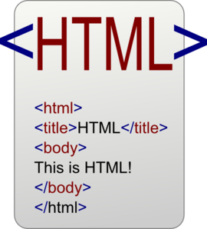

**Fig 2.6: HTML Structure**

HTML gives authors the means to:

* Publish online documents with headings, text, tables, lists, photos, etc.
* Retrieve online information via hypertext links, at the click of a button.
* Design forms for conducting transactions with remote services, for use in searching for information, making reservations, ordering products, etc.
* Include spread-sheets, video clips, sound clips, and other applications directly in their documents.

HTML was originally developed by Tim Berners-Lee while at CERN, and popularized by the Mosaic browser developed at NCSA. During the course of the 1990s it has blossomed with the explosive growth of the Web. During this time, HTML has been extended in a number of ways. The Web depends on Web page authors and vendors sharing the same conventions for HTML. This has motivated joint work on specifications for HTML.

It is a platform independent language that can be used on any platform such as Windows, Linux, Macintosh, and so on. To display a document in web it is essential to mark-up the different elements (headings, paragraphs, tables, and so on) of the document with the HTML tags. To view a mark-up document, user has to open the document in a browser. A browser understands and interpret the HTML tags, identifies the structure of the document (which part are which) and makes decision about presentation (how the parts look) of the document.

**XHTML**

• XHTML stands for Extensible Mark-up Language

• XHTML is a mark-up language much like HTML

• XHTML was designed to carry data, not to display data

• XHTML tags are not predefined. We must define your own tags

• XHTML is designed to be self-descriptive

**CSS**

It is a [style sheet language](https://en.wikipedia.org/wiki/Style_sheet_language) used for describing the [presentation](https://en.wikipedia.org/wiki/Presentation_semantics) of a document written in a [mark-up language](https://en.wikipedia.org/wiki/Markup_language). Although most often used to set the visual style of [web pages](https://en.wikipedia.org/wiki/Web_page) and user interfaces written in [HTML](https://en.wikipedia.org/wiki/HTML) and [XHTML](https://en.wikipedia.org/wiki/XHTML), the language can be applied to any [XML](https://en.wikipedia.org/wiki/XML) document, including [plain XML](https://en.wikipedia.org/wiki/Plain_Old_XML), [SVG](https://en.wikipedia.org/wiki/Scalable_Vector_Graphics) and [XUL](https://en.wikipedia.org/wiki/XUL), and is applicable to rendering in [speech](https://en.wikipedia.org/wiki/Speech_synthesis), or on other media. Along with HTML and [JavaScript](https://en.wikipedia.org/wiki/JavaScript), CSS is a cornerstone technology used by most websites to create visually engaging Webpages, user interfaces for [web applications](https://en.wikipedia.org/wiki/Web_applications), and user interfaces for many mobile applications.

CSS is designed primarily to enable [the separation of document content from document presentation](https://en.wikipedia.org/wiki/Separation_of_presentation_and_content), including aspects such as the [layout](https://en.wikipedia.org/wiki/Page_layout), [colours](https://en.wikipedia.org/wiki/Color), and [fonts](https://en.wikipedia.org/wiki/Typeface) This separation can improve content [accessibility](https://en.wikipedia.org/wiki/Accessibility), provide more flexibility and control in the specification of presentation characteristics, enable multiple HTML pages to share formatting by specifying the relevant CSS in a separate .css file, and reduce complexity and repetition in the structural content.

Separation of formatting and content makes it possible to present the same mark-up page in different styles for different rendering methods, such as on-screen, in print, by voice (via speech-based browser or [screen reader](https://en.wikipedia.org/wiki/Screen_reader)), and on [Braille-based](https://en.wikipedia.org/wiki/Braille_display) tactile devices. It can also display the web page differently depending on the screen size or viewing device. Readers can also specify a different style sheet, such as a CSS file stored on their own computer, to override the one the author specified.

Changes to the [graphic design](https://en.wikipedia.org/wiki/Graphic_design) of a document (or hundreds of documents) can be applied quickly and easily, by editing a few lines in the CSS file they use, rather than by changing mark-up in the documents.

The CSS specification describes a priority scheme to determine which style rules apply if more than one rule matches against a particular element. In this so-called cascade, priorities (or weights) are calculated and assigned to rules, so that the results are predictable.

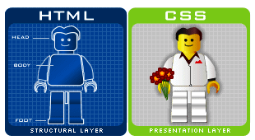

**Fig 2.7: HTML To CSS**

**JQUERY**

**What is jQuery**

jQuery is a small, light-weight and fast JavaScript library. It is cross-platform and supports different types of browsers. It is also referred as ?write less do more? because it takes a lot of common tasks that requires many lines of JavaScript code to accomplish, and binds them into methods that can be called with a single line of code whenever needed. It is also very useful to simplify a lot of the complicated things from JavaScript, like AJAX calls and DOM manipulation.

* jQuery is a small, fast and lightweight JavaScript library.
* jQuery is platform-independent.
* jQuery means "write less do more".
* jQuery simplifies AJAX call and DOM manipulation.



**Fig 2.8: jQuery Symbol**

**jQuery Features**

Following are the important features of jQuery.

* HTML manipulation
* DOM manipulation
* DOM element selection
* CSS manipulation
* Effects and Animations
* Utilities
* AJAX
* HTML event methods
* JSON Parsing
* Extensibility through plug-ins

**Why jQuery is required**

Sometimes, a question can arise that what is the need of jQuery or what difference it makes on bringing jQuery instead of AJAX/ JavaScript? If jQuery is the replacement of AJAX and JavaScript? For all these questions, you can state the following answers.

* It is very fast and extensible.
* It facilitates the users to write UI related function codes in minimum possible lines.
* It improves the performance of an application.
* Browser's compatible web applications can be developed.
* It uses mostly new features of new browsers.

So, you can say that out of the lot of JavaScript frameworks, jQuery is the most popular and the most extendable. Many of the biggest companies on the web use jQuery.

Some of these companies are:

* Microsoft
* Google
* IBM
* Netflix

**What should you know before starting to learn jQuery?**

It is always advised to a fresher to learn the basics of web designing before starting to learn jQuery. He should learn HTML, CSS and JavaScript first. But, if you belong to a technical background, it is up to you.

If you are a fresher and want to study these subjects first.



**Fig 2.9: jQuery Requirements**

**EXTERNAL APIS USED**

**ADAFRUIT FOR ARDUINO**

Adafruit library is basically used to play around with adafruit devices like Fingerprint sensors, RFID scanners, NFC etc. In our project it is used to interfere with R305 biometric module.

This library features some methods to

* Enrol new fingerprint into R305
* Delete any fingerprint
* Clearing the database of R305
* Retrieve the ID where a certain fingerprint is stored

**ANDROID USB SERIAL API**

This API allows any android device for serial communication with devices like Arduino.

UsbSerial internals: A brief description

* Internally UsbSerial works as a Producer-Consumer handler,  what you write is put into a buffer and it will be consumed by a Consumer thread when previous data is sent.
* Write operations can be queued from multiple threads without problems
* Received data is received through a callback, there is no need to be polling.
* Two 16kb internal buffers for Write and Read operations.
* Android 4.2.1  or greater devices rely on Asynchronous USB api for read operations. Prior versions (Android 3.1 oldest version supported) use synchronous api due to some Android bugs. Write operations use always synchronous USB api. UsbSerial handles all of this so there is no need to worry.
* PL2303, FT232 and CP210x drivers use a list of known vid and pids to identify a correct device.
* CDC driver can be loaded automatically for a device if it has a CDC interface.

**BOOTSTRAP FOR HTML GUI DESIGNING**

Bootstrap is an open-source JavaScript framework developed by the team at Twitter. It is a combination of HTML, CSS, and JavaScript code designed to help build user interface components. Bootstrap was also programmed to support both HTML5 and CSS3.

Also it is called Front-end-framework.

Bootstrap is a free collection of tools for creating websites and web applications.

It contains HTML and CSS-based design templates for typography, forms, buttons, navigation and other interface components, as well as optional JavaScript extensions.

Some Reasons for programmers preferred Bootstrap Framework

* Easy to get started
* Great grid system
* Base styling for most HTML elements(Typography, Code, Tables, Forms, Buttons, Images, Icons)
* Extensive list of components
* Bundled JavaScript plug-ins

**HARDWARES USED**

**ARDUINO UNO R3**

**Arduino Uno**

It is a microcontroller board based on the ATmega328P ([datasheet](http://www.atmel.com/Images/doc8161.pdf)). It has 14 digital input/output pins (of which 6 can be used as PWM outputs), 6 analog inputs, a 16 MHz quartz crystal, a USB connection, a power jack, an ICSP header and a reset button. It contains everything needed to support the microcontroller; simply connect it to a computer with a USB cable or power it with a AC-to-DC adapter or battery to get started.. You can tinker with your UNO without worring too much about doing something wrong, worst case scenario you can replace the chip for a few dollars and start over again.

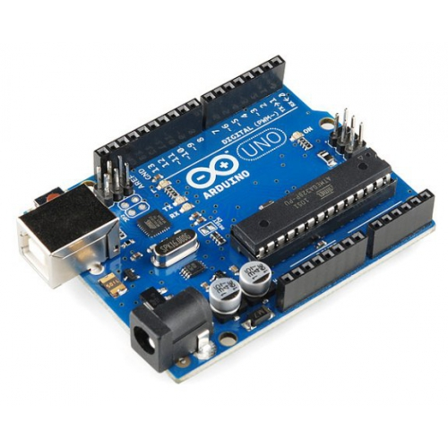

**Fig 2.10: Arduino UNO**

"Uno" means one in Italian and was chosen to mark the release of Arduino Software (IDE) 1.0. The Uno board and version 1.0 of Arduino Software (IDE) were the reference versions of Arduino, now evolved to newer releases. The Uno board is the first in a series of USB Arduino boards, and the reference model for the Arduino platform; for an extensive list of current, past or outdated boards see the Arduino index of boards.

**Getting Started**

You can find in the [Getting Started section](https://www.arduino.cc/en/Guide/HomePage) all the information you need to configure your board, use the Arduino Software (IDE), and start tinker with coding and electronics.

**Technical Specifications**

|  |  |
| --- | --- |
| Microcontroller | [ATmega328P](http://www.atmel.com/Images/Atmel-42735-8-bit-AVR-Microcontroller-ATmega328-328P_Datasheet.pdf) |
| Operating Voltage | 5V |
| Input Voltage (recommended) | 7-12V |
| Input Voltage (limit) | 6-20V |
| Digital I/O Pins | 14 (of which 6 provide PWM output) |
| PWM Digital I/O Pins | 6 |
| Analog Input Pins | 6 |
| DC Current per I/O Pin | 20 mA |
| DC Current for 3.3V Pin | 50 mA |
| Flash Memory | 32 KB (ATmega328P) of which 2KB used by bootloader |
| SRAM | 2 KB (ATmega328P) |
| EEPROM | 1 KB (ATmega328P) |
| Clock Speed | 16 MHz |
| LED_BUILTIN | 13 |
| Length | 68.6 mm |
| Width | 53.4 mm |
| Weight | 25 g |

**Table 2.2: Specifications of Arduino**

**R305 BIOMETRIC MODULE**

**R305 Sensor**

This is a fingure print sensor module with TTL UART interface for direct connections to microcontroller UART or to PC through MAX232 / USB-Serial adapter. The user can store the finger print data in the module and can configure it in 1:1 or 1: N mode for identifying the person.The FP module can directly interface with 3v3 or 5v Microcontroller. A level converter (like MAX232) is required for interfacing with PC serial port.

Optical biometric fingerprint reader with great features and can be embedded into a variety of end products, such as: access control, attendance, safety deposit box, car door locks

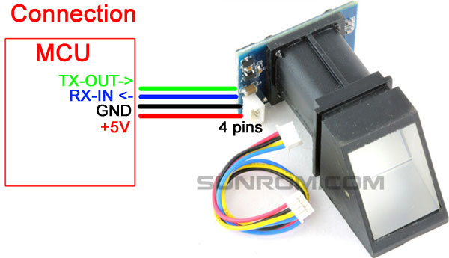

**Fig 2.11 R305 Module**

**Features**

* Integrated image collecting and algorithm chip together, ALL-in-One
* Fingerprint reader can conduct secondary development, can be embedded into a variety of end products
* Low power consumption, low cost, small size, excellent performance
* Professional optical technology, precise module manufacturing techniques
* Good image processing capabilities, can successfully capture image up to resolution 500 dpi

**Technical Specifications**

|  |  |
| --- | --- |
| Fingerprint sensor type | Optical |
| Sensor Life | 100 million times |
| Static indicators | 15KVBacklight: bright green |
| Interface | USB1.1/UART(TTL logical level) |
| RS232 communication baud rate | 4800BPS~115200BPS changeable |
| Dimension | 55*32*21.5mm |
| Image Capture Surface | 15—18(mm) |
| Verification Speed | 0.3 sec |
| Scanning Speed | 0.5 sec |
| Character file size | 256 bytes |
| Template size | 512 bytes |
| Storage capacity | 162 |
| Security level | 5 (1,2,3,4,5(highest)) |
| False Acceptance Rate (FAR) | 0.00% |
| False Rejection Rate (FRR) | 0.10% |
| Resolution | 500 DPI |
| Voltage | 3.6-6.0 VDC |
| Working current | Typical 90 mA, Peak 150mA |
| Matching Method | 1: N |
| Operating Environment Temperature | -20 to 45° centigrades |

**Table 2.3: Specifications of R305**

**Chapter 3**

**PROBLEM IDENTIFICATION OBJECTIVES**

**PROBLEM IDENTIFICATION**

At the moment, the current system in lecture or lab session, lecturer will pass the students name list to sign in for student who attends that class. Or the lecturer will call the student no. In this Falsify of student signature or giving fake attendance during roll call is frequently and easily happened.

Another technology is using a smart card for attendance but in this too false attendance can be given by ‘buddy swiping’.

So, to prevent this problem, it is ideal to develop the attendance management system using biometric fingerprint recognition that will monitor and record the attendance of every student in class. The barcode is easy to produce and duplicate, but fingerprint is unique for everyone. Even this systems are implemented at various places but the limitations are there is no centralized database to record all the attendance and the biometric unit itself is fixed at one place.

The main problems faced in organizations are:

* There is no efficient and effective attendance management system.
* There is no system which maintain perfect attendance into centralized database
* There is no system which provide Internet based communication
* There is no system which track the manipulation of attendance
* There is no system which detect or doesn’t allow false attendance
* There is no reliable portable system
* There is no such system which view the daily, monthly and yearly attendance reports of all locations
* There is no system which take attendance from various locations using Biometric Fingerprint Device.

**OBJECTIVES**

This paper presents the attendance management system using fingerprint technology in a company or organization environment. It consists of two processes namely; enrolment and authentication. During enrolment, the fingerprint of the user is captured and its unique features extracted and stored in a database along with the user’s identity as a template. And during authentication the authentication module validates the identity of the person who intends to access the system.

The main objective of this project is to:

* To provide an efficient and effective attendance management system.
* To maintain perfect attendance into centralized database
* To provide Internet based communication
* To avoid manipulation of attendance
* To make cheats impossible
* To make a portable device
* To view daily, monthly and yearly attendance reports of all locations.
* To take attendance from various locations using Biometric Fingerprint Device.

**Chapter 4**

**LITERATURE SURVEY**

**LITERATURE SURVEY**

A fingerprint is an impression or mark made on a surface by a person's fingertip, able to be used for identifying individuals from the unique pattern of whorls and lines on the fingertips.

Fingerprint recognition or fingerprint authentication refers to the automated method of verifying a match between two human fingerprints. Fingerprints are one of many forms of biometrics used to identify individuals and verify their identity.

Attendance Management System is software developed for daily employee attendance in office and institutes. It facilitates to access the attendance information of a particular employee in a particular department. The information is sorted by the main admin, which will be provided by the sub admin for a particular department. This system will also help in evaluating attendance eligibility criteria of an employee. Since ages, attendance system has remained one of the most important systems for evaluating the working time of employees in any office or institute. In short, this project is used to mark the number of days present/absent in a year of employees in an office/institutes. And this system will also help in evaluating attendance eligibility criteria of a student. Nowadays, due to the large number of workers/employees, it is efficient to use attendance management system to manage attendance in office/institute.

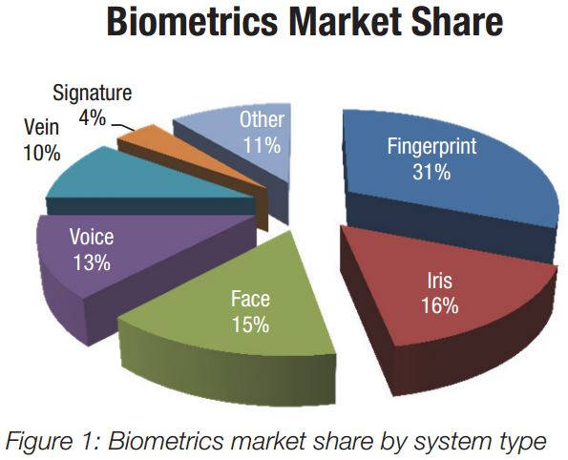

**Fig 4.1: Biometric Usages in 2016**

According to the above market distribution in the year 2016 the most reliable biometric technology used is Fingerprint.

**Chapter 5**

**METHODOLOGIES**

**METHOD USED- ITERATIVE MODEL**

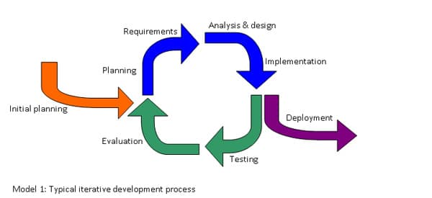

**Fig 5.1 Iterative Model Process**

With the [Iterative model](https://www.testingexcellence.com/iterative-model/), software is built in small chunks, each time adding more functionality. Unlike the waterfall model which requires fully specified requirements before starting the implementation, with the Iterative model, you implement a small set of software requirements, then test, evaluate and refine the requirements.

With each iteration, new requirements are added and a new version of the software is produced. This process is repeated until the application is fully developed and all requirements implemented.

One advantage of Iterative model over the other SDLC methodologies is that we get a working version of the application early in the process and so it less expensive to implement changes.

One disadvantage is that resources can quickly be eaten up by repeating the process again and again.

**The Process**

Unlike the more traditional waterfall model, which focuses on a stringent step-by-step process of development stages, the iterative model is best thought of as a cyclical process. After an initial planning phase, a small handful of stages are repeated over and over, with each completion of the cycle incrementally improving and iterating on the software. Enhancements can quickly be recognized and implemented throughout each iteration, allowing the next iteration to be at least marginally better than the last.

* **Planning & Requirements**: As with most any development project, the first step is go through an initial planning stage to map out the specification documents, establish software or hardware requirements, and generally prepare for the upcoming stages of the cycle.
* **Analysis & Design**: Once planning is complete, an analysis is performed to nail down the appropriate business logic, database models, and the like that will be required at this stage in the project. The design stage also occurs here, establishing any technical requirements (languages, data layers, services, etc.) that will be utilized in order to meet the needs of the analysis stage.
* **Implementation**: With the planning and analysis out of the way, the actual implementation and coding process can now begin. All planning, specification, and design docs up to this point are coded and implemented into this initial iteration of the project.
* **Testing**: Once this current build iteration has been coded and implemented, the next step is to go through a series of testing procedures to identify and locate any potential bugs or issues that have cropped up.
* **Evaluation**: Once all prior stages have been completed, it is time for a thorough evaluation of development up to this stage. This allows the entire team, as well as clients or other outside parties, to examine where the project is at, where it needs to be, what can or should change, and so on.
* Now the real fun begins! This is the crux of the entire iterative model, whereby the most recently built iteration of the software, as well as all feedback from the evaluation process, is brought back to the planning & development stage at the top of the list, and the process repeats itself all over again.

**Advantages of the Iterative Model**

* **Inherent Versioning**: It is rather obvious that most software development life cycles will include some form of versioning, indicating the release stage of the software at any particular stage. However, the iterative model makes this even easier by ensuring that newer iterations are incrementally improved versions of previous iterations. Moreover, in the event that a new iteration fundamentally breaks a system in a catastrophic manner, a previous iteration can quickly and easily be implemented or “rolled back,” with minimal losses; a particular boon for post-release maintenance or web applications.
* **Rapid Turnaround**: While it may seem like each stage of the iterative process isn’t all that different from the stages of a more traditional model like the waterfall method — and thus the process will take a great deal of time — the beauty of the iterative process is that each stage can effectively be slimmed down into smaller and smaller time frames; whatever is necessary to suit the needs of the project or organization. While the initial run through of all stages may take some time, each subsequent iteration will be faster and faster, lending itself to that agile moniker so very well, and allowing the life cycle of each new iteration to be trimmed down to a matter of days or even hours in some cases.
* **Suited for Agile Organizations**: While a step-by-step process like the waterfall model may work well for large organizations with hundreds of team members, the iterative model really starts to shine when its in the hands of a smaller, more agile team. Particularly when combined with the power of modern version control systems, a full “iteration process” can effectively be performed by a number of individual team members, from planning and design through to implementation and testing, with little to no need for outside feedback or assistance.
* **Easy Adaptability**: Hinging on the core strength of constant, frequent iterations coming out on a regular basis, another primary advantage of the iterative model is the ability to rapidly adapt to the ever-changing needs of both the project or the whims of the client. Even fundamental changes to the underlying code structure or implementations (such as a new database system or service implementation) can typically be made within a minimal time frame and at a reasonable cost, because any detrimental changes can be recognized and reverted within a short time frame back to a previous iteration.

**Disadvantages of the Iterative Model**

* **Costly Late-Stage Issues**: While not necessarily a problem for all projects, due to the minimal initial planning before coding and implementation begin, when utilizing an iterative model, it is possible that an unforeseen issue in design or underlying system architecture will arise late into the project. Resolving this could have potentially devastating effects on the time frame and costs of the project as a whole, requiring a great deal of future iterations just to resolve one issue.
* **Increased Pressure on User Engagement**: Unlike the waterfall model, which emphasizes nearly all user/client engagement within the initial stages of the project during a brief crunch time period, the iterative model often requires user engagement throughout the entirety of the process. This is sometimes an unfortunate obligation, since each new iteration will likely require testing and feedback from users in order to properly evaluate any necessary changes.
* **Feature Creep**: Not only does the iterative model require user feedback throughout the process, but this also inherently means the project may be subject to undesired feature creep, whereby users experience the changes in each iteration, and are inclined to constantly put forth new requests for additional features to be added to future versions.

**DESIGN MODEL**

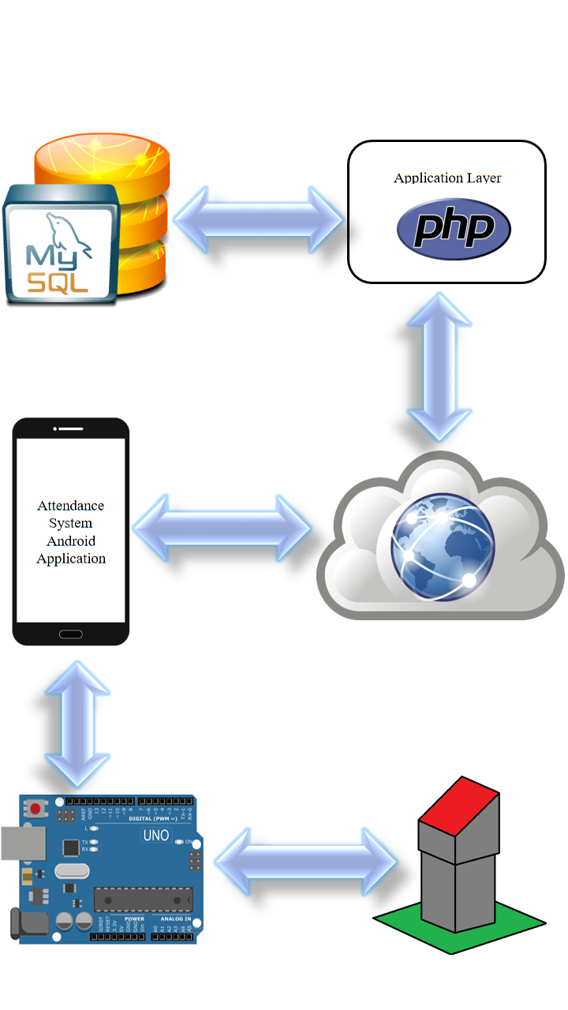

**Fig 5.2 Design Model**

**BUSINESS PROCESS MODEL**

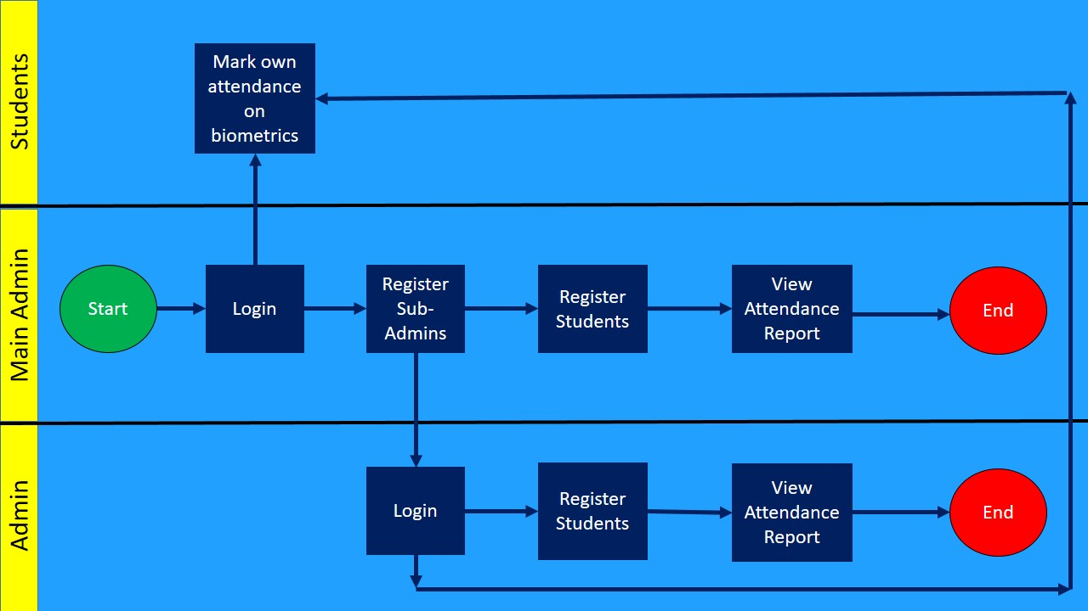

**Fig 5.3 Business Process Model**

**ER DIAGRAM**

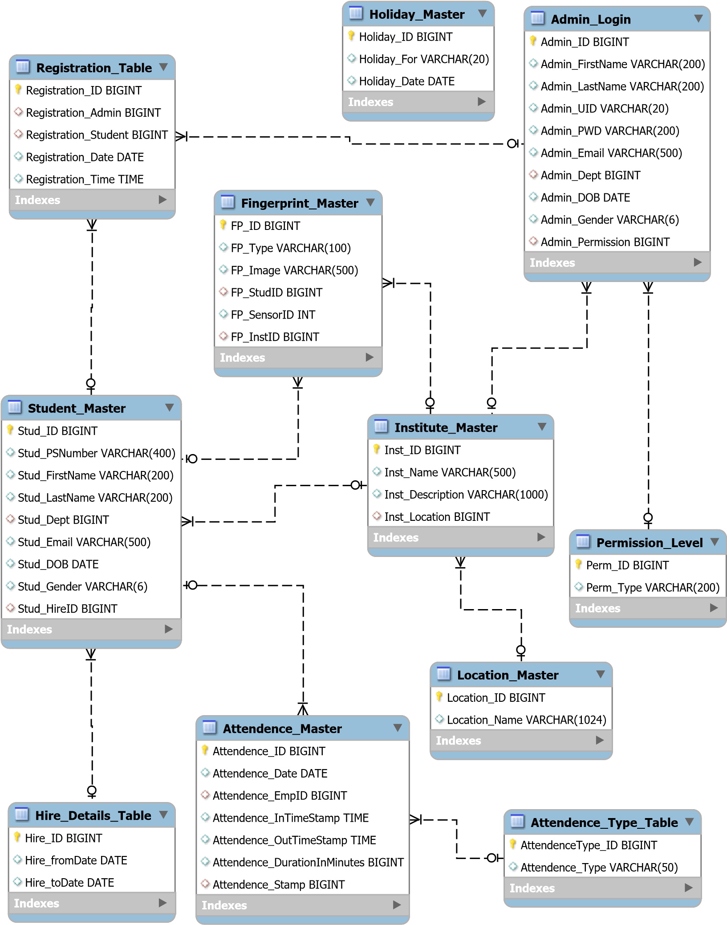

**Fig 5.4: Database ER Diagram**

**DFD DIAGRAM**

**Data Flow Diagram- Level 0**

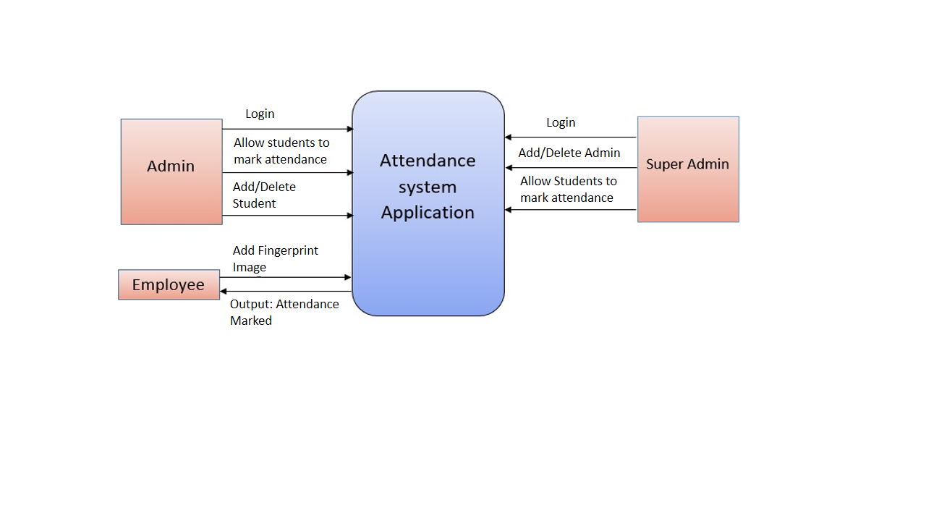

**Fig 5.5 (a): DFD Level 0**

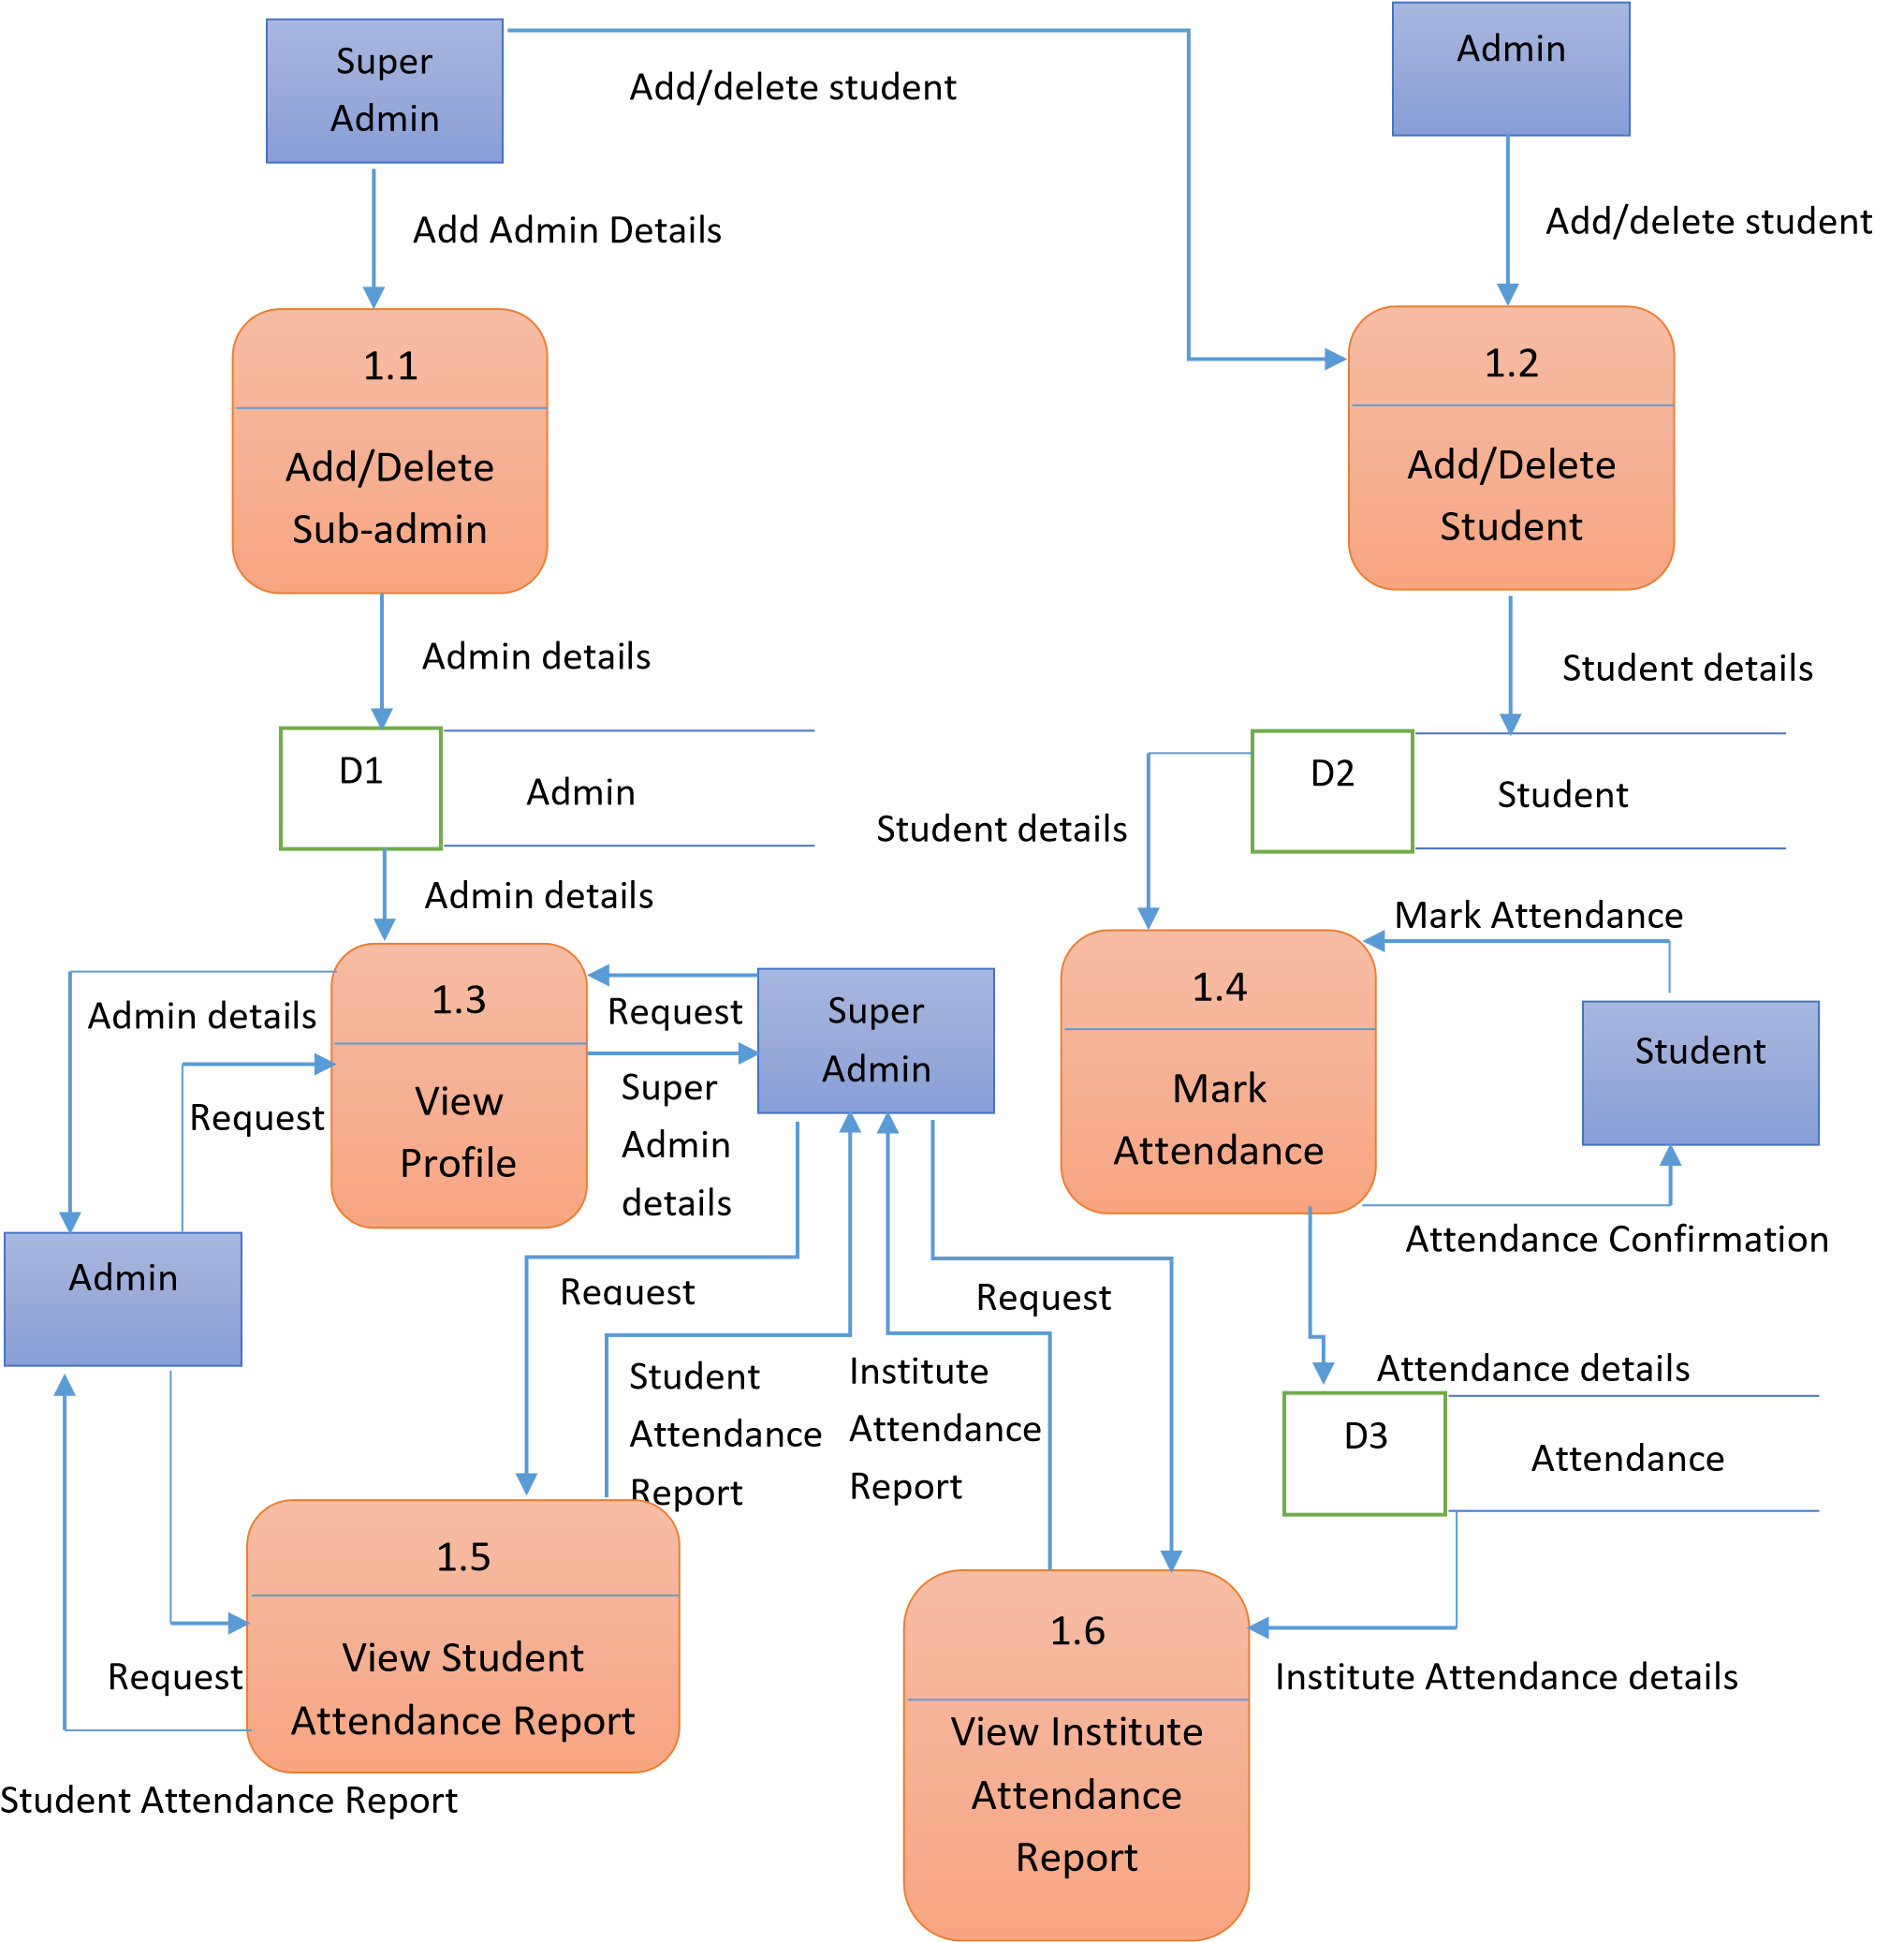

**Fig 5.5 (b): DFD Level 1**

**FLOW CHARTS**

**FLOW CHART FOR ARDUINO UNO**

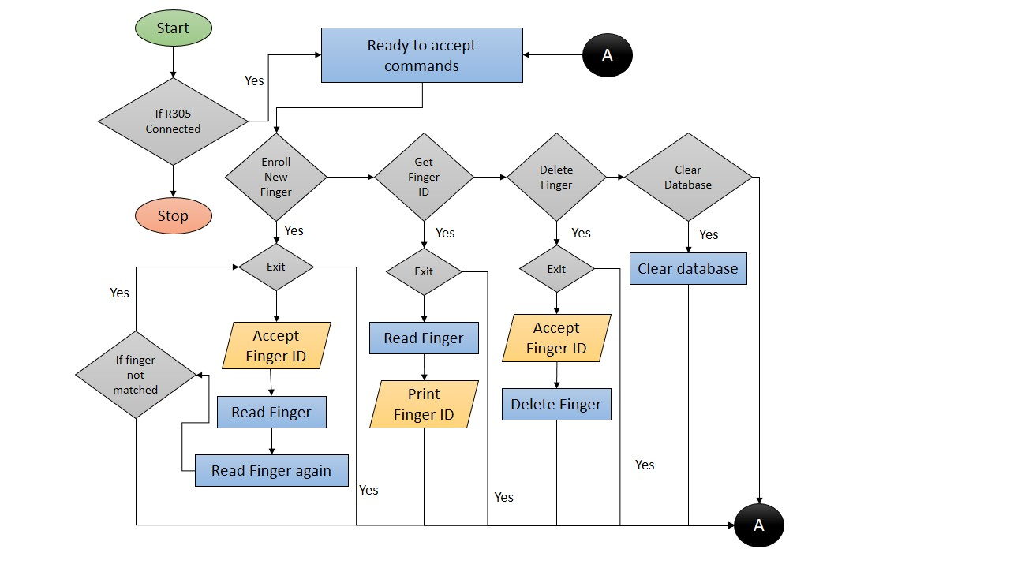

**Fig 5.6: Arduino UNO Flow Chart**

**FLOW CHART FOR BIOMETRIC ANDROID APP**

**Initial Process**

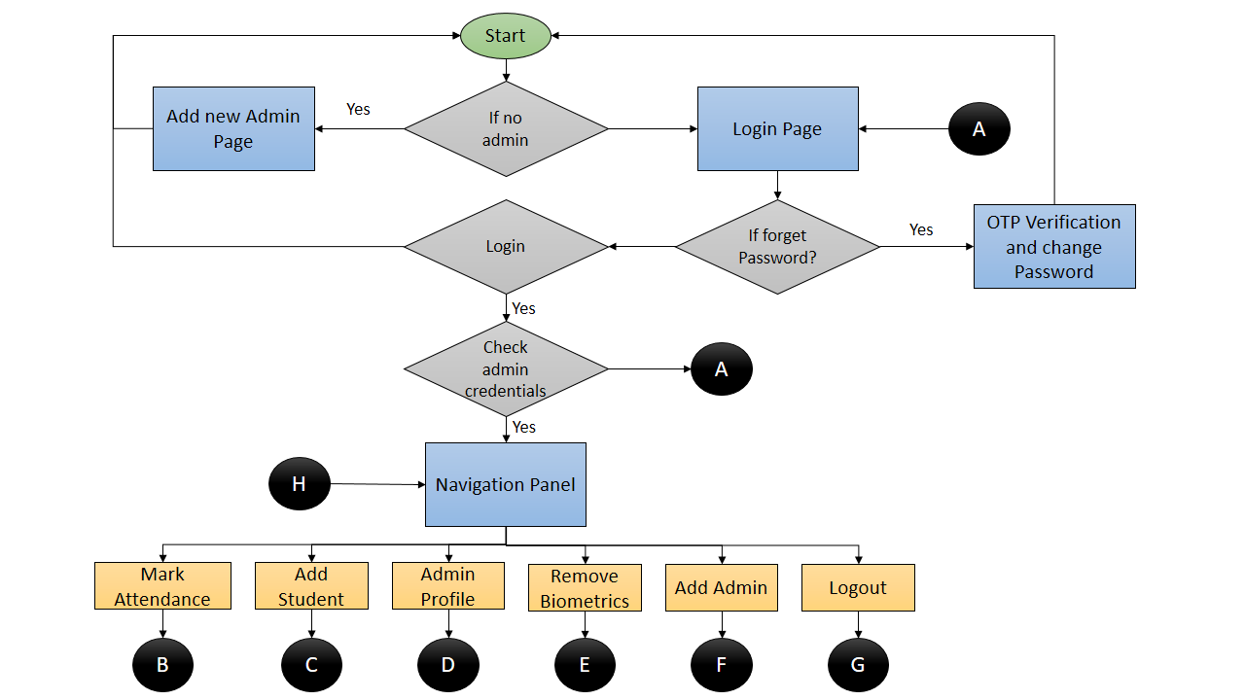

**Fig 5.7 (a): Android App Beginning**

**Attendance Marking**

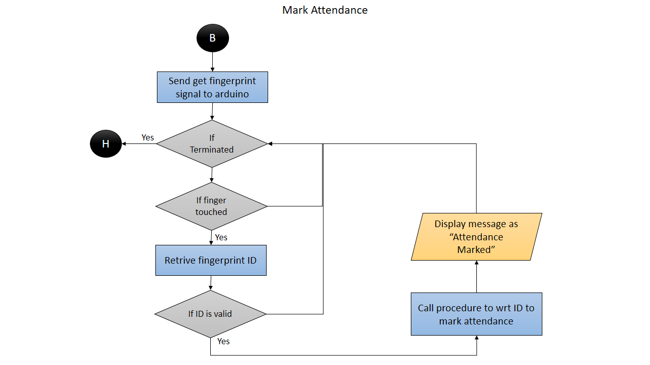

**Fig 5.7 (b): Attendance Marking**

**Adding New Student**

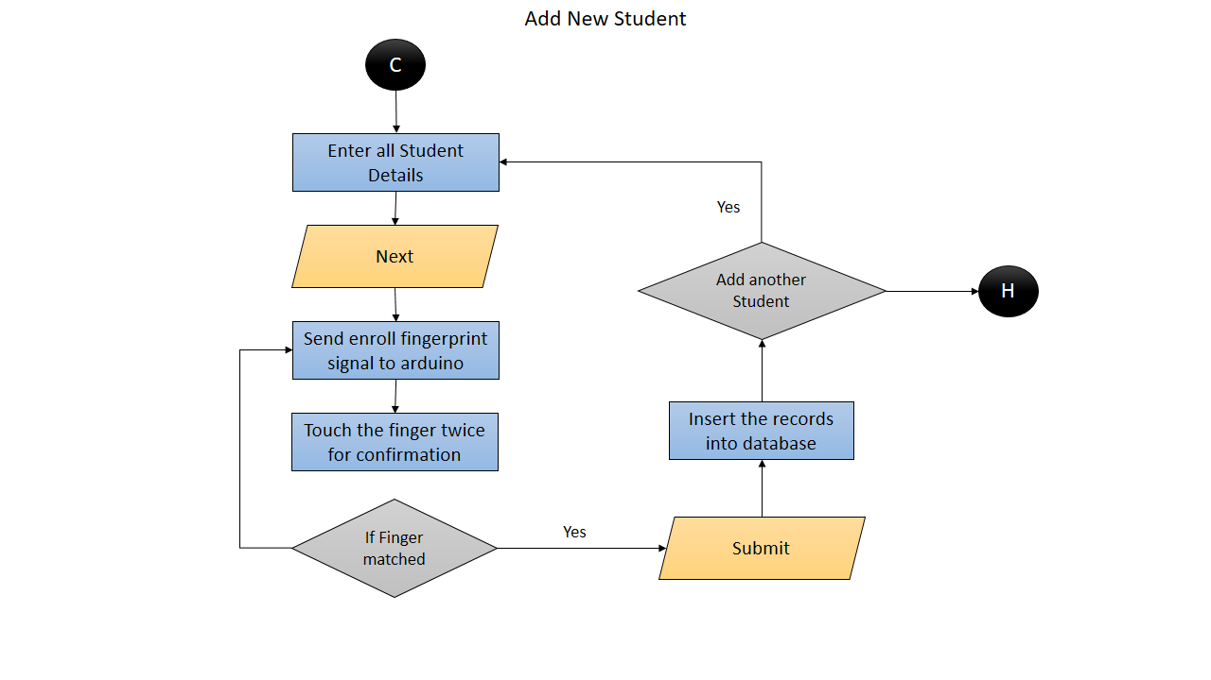

**Fig 5.7 (c): Enrolling New Student**

**Editing and Viewing Admin Profile**

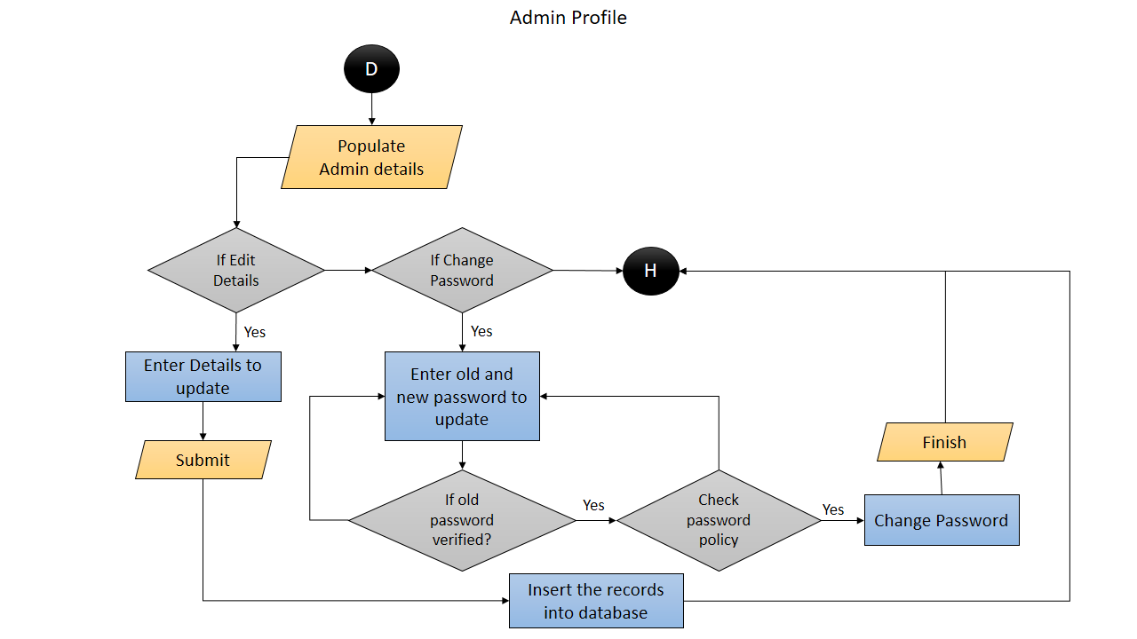

**Fig 5.7 (d): Editing and Viewing Admin Profile**

**Remove Student Biometrics**

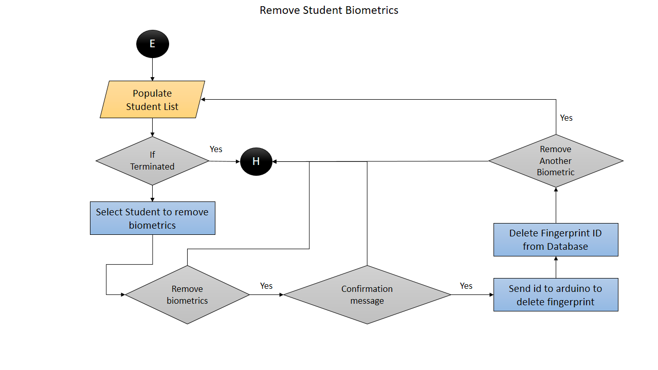

**Fig 5.7 (e): Removing Student Biometrics**

**Add New Admin**

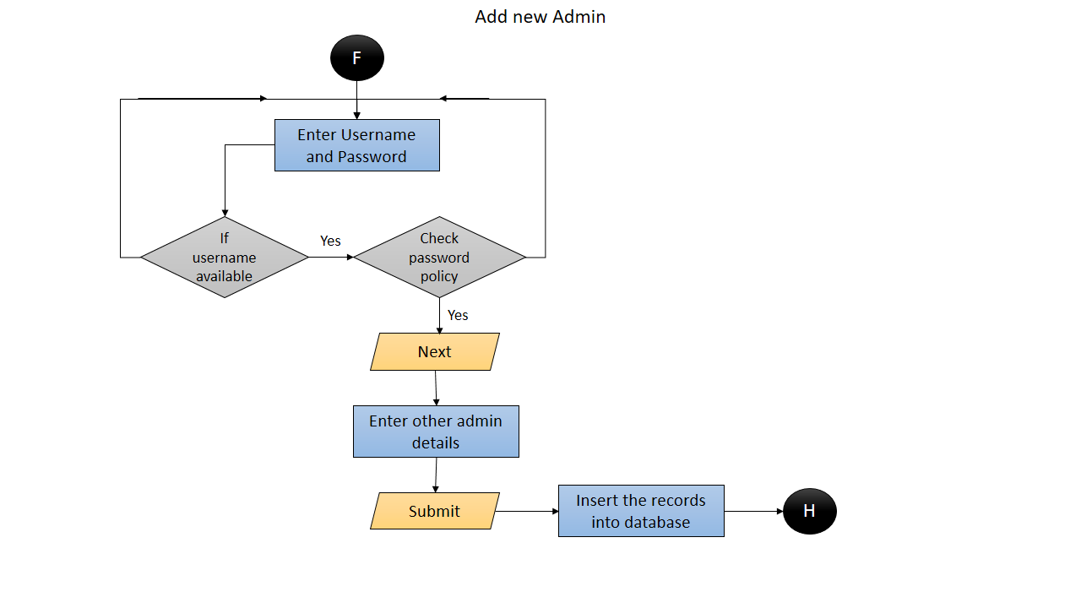

**Fig 5.7 (f): Adding New Admin**

**Logout**

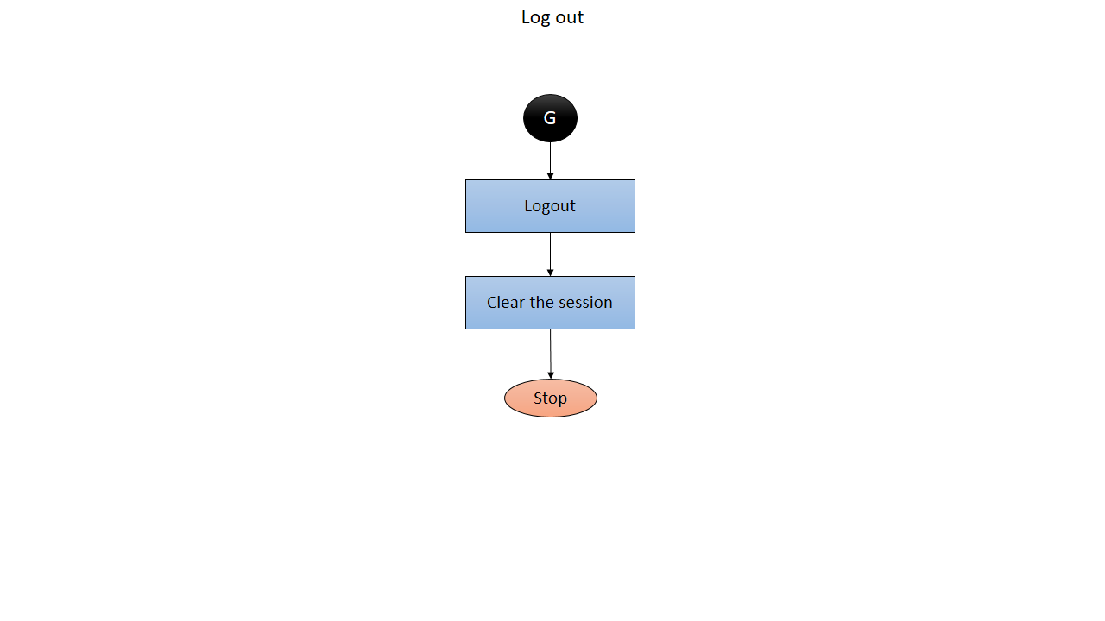

**Fig 5.7 (g): Logging Out**

**FLOW CHART FOR BIOMETRIC REPORTING**

**Initial Process**

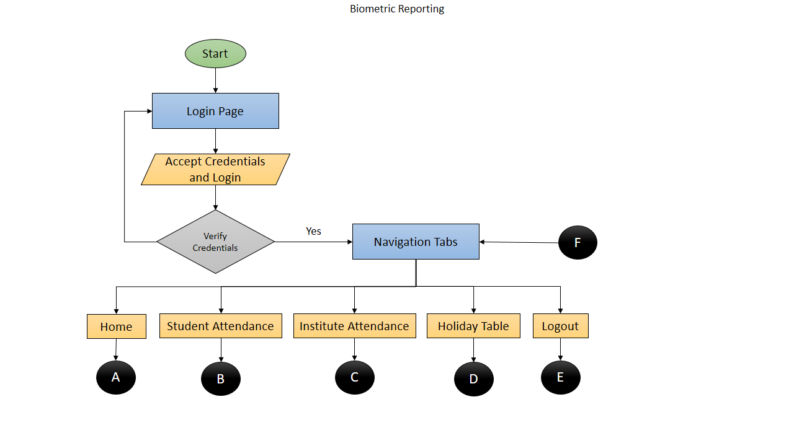

**Fig 5.8 (a): Biometric Reporting Beginning**

**Home Page**

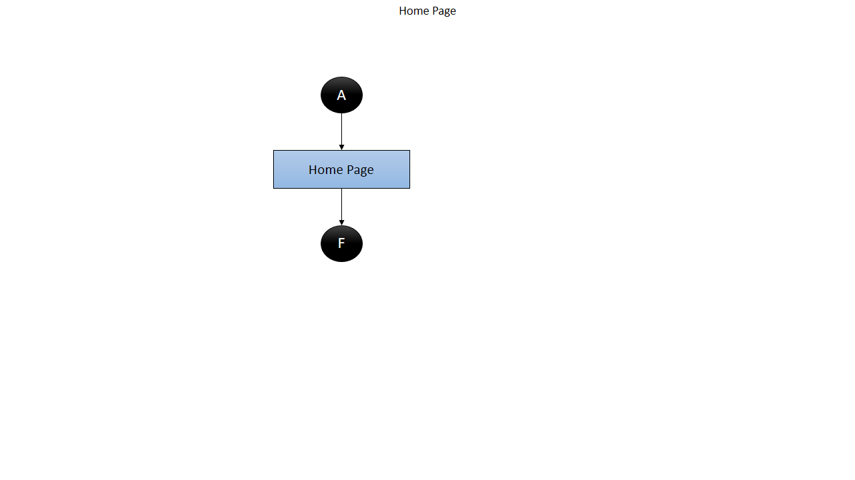

**Fig 5.8 (b): Home Page**

**Student Attendance**

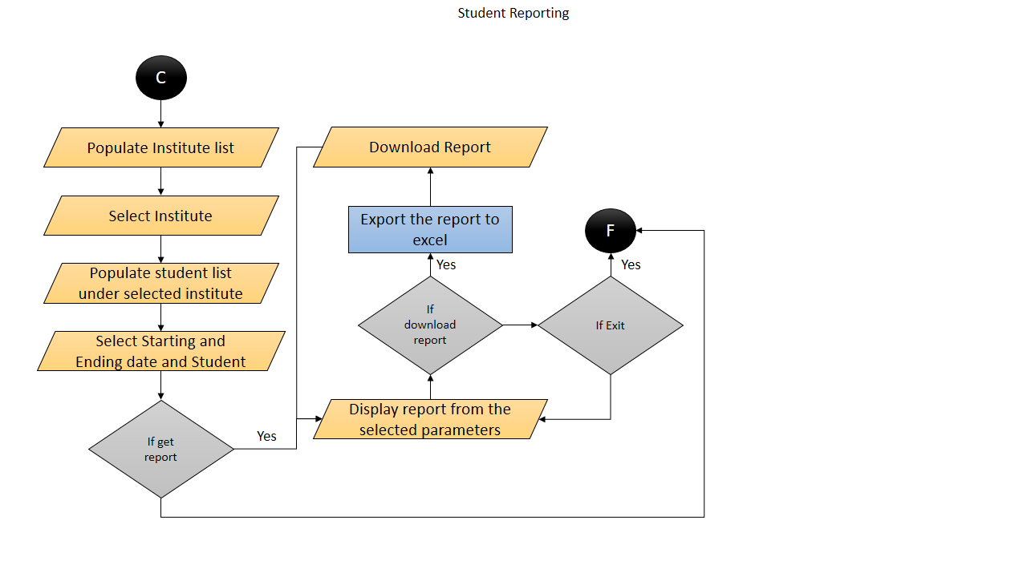

**Fig 5.8 (c): Student Attendance**

**Institute Attendance**

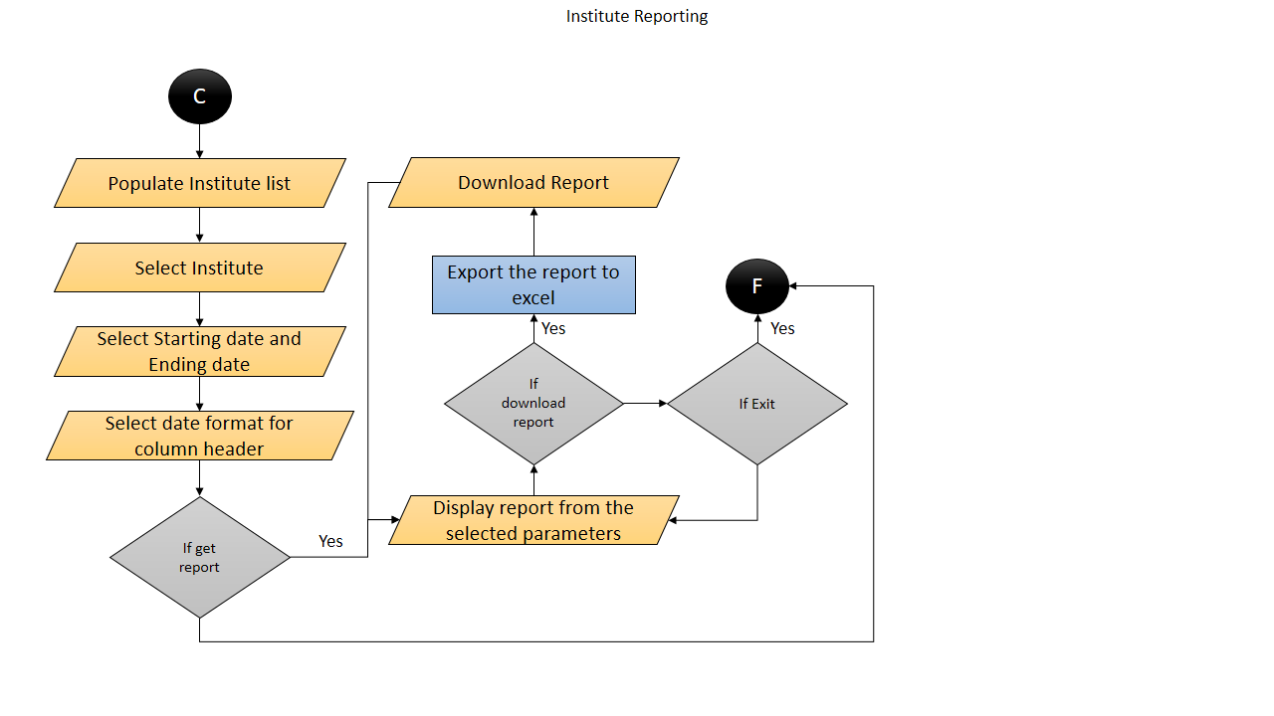

**Fig 5.8 (d): Institute Attendance**

**Holiday Master**

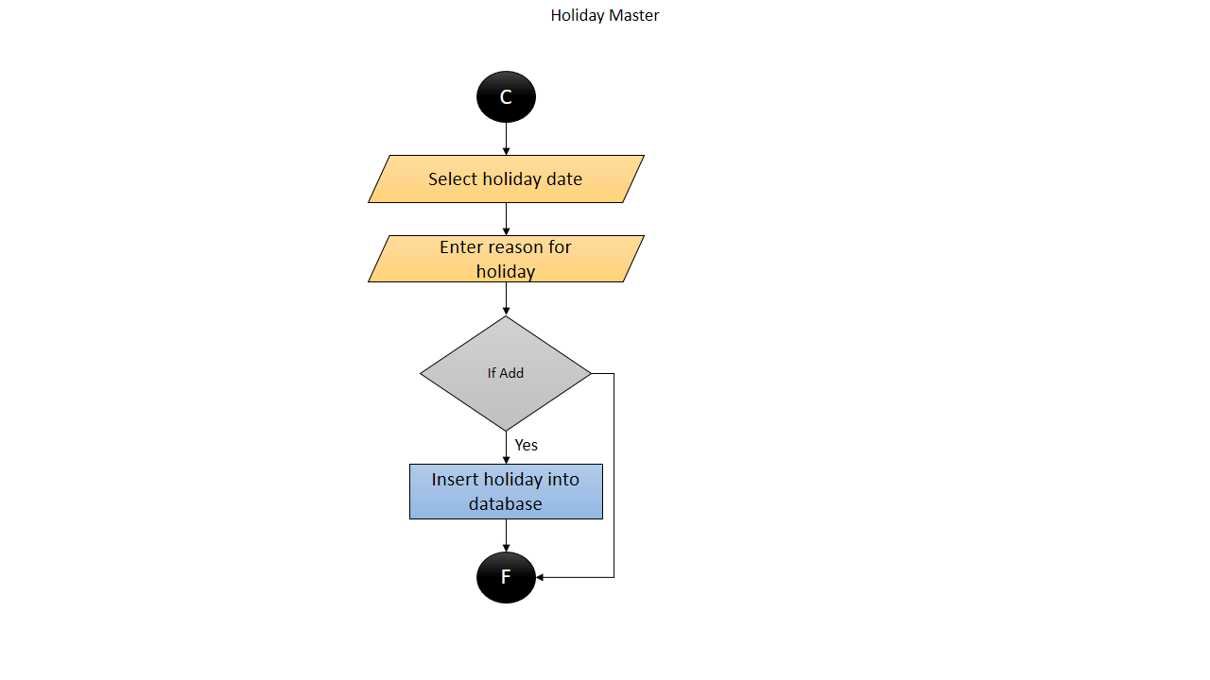

**Fig 5.8 (e): Holiday Master**

**Logout**

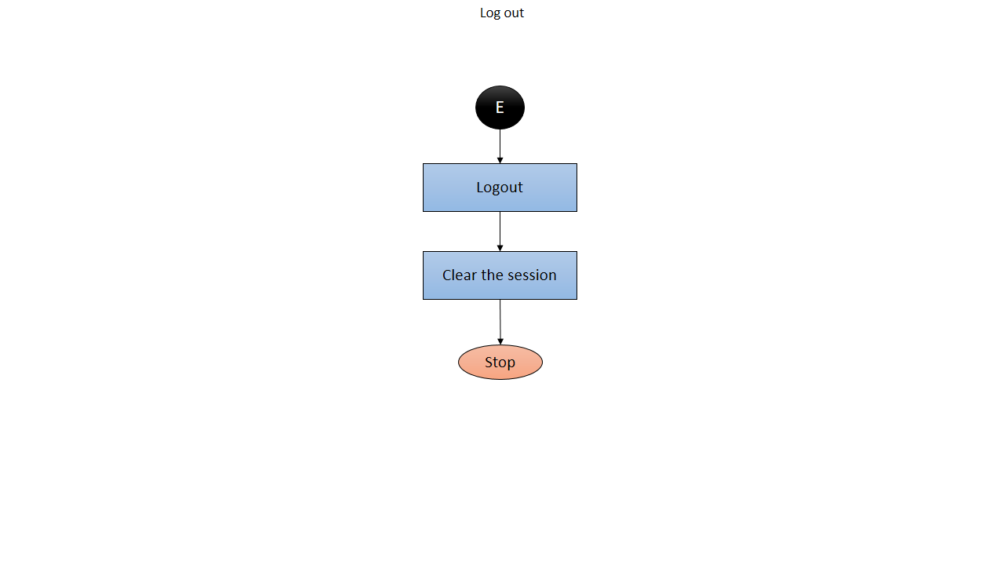

**Fig 5.8 (f): Logging out**

**Chapter 6**

**RESULT ANALYSIS AND IMPLEMENTATION**

**CHALLENGES FACED AND SOLUTIONS**

**PASSWORD SECURITY**

**Problem**

In our system we have given the login access for administrator so that he can add new admins, add students, view reports, mark the attendance, and remove certain student’s biometric. Every time he logins there is a need to verify his/her credentials which is stored in the database. Even when adds new admin his/her password is supposed to be stored into the database. So it was not safe to transfer passwords directly from android to server or vice versa.

**Solution**

To overcome this problem we have created our own message digest algorithm which creates the message digest of password and sends it to database. So in database this message digest is stored rather than storing actual password. So now it is impossible to retrieve or read the password stored into database.

**How the password is verified?**

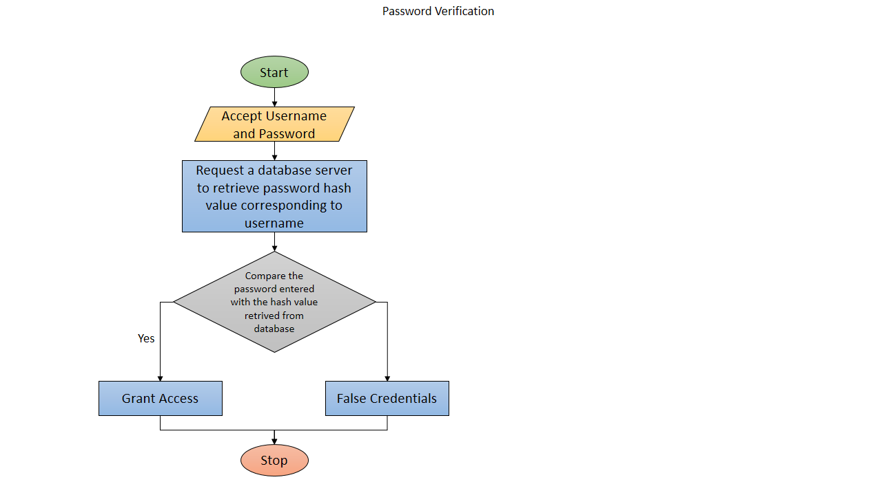

**Fig 6.1: Password Verification**

**How new admin is registered?**

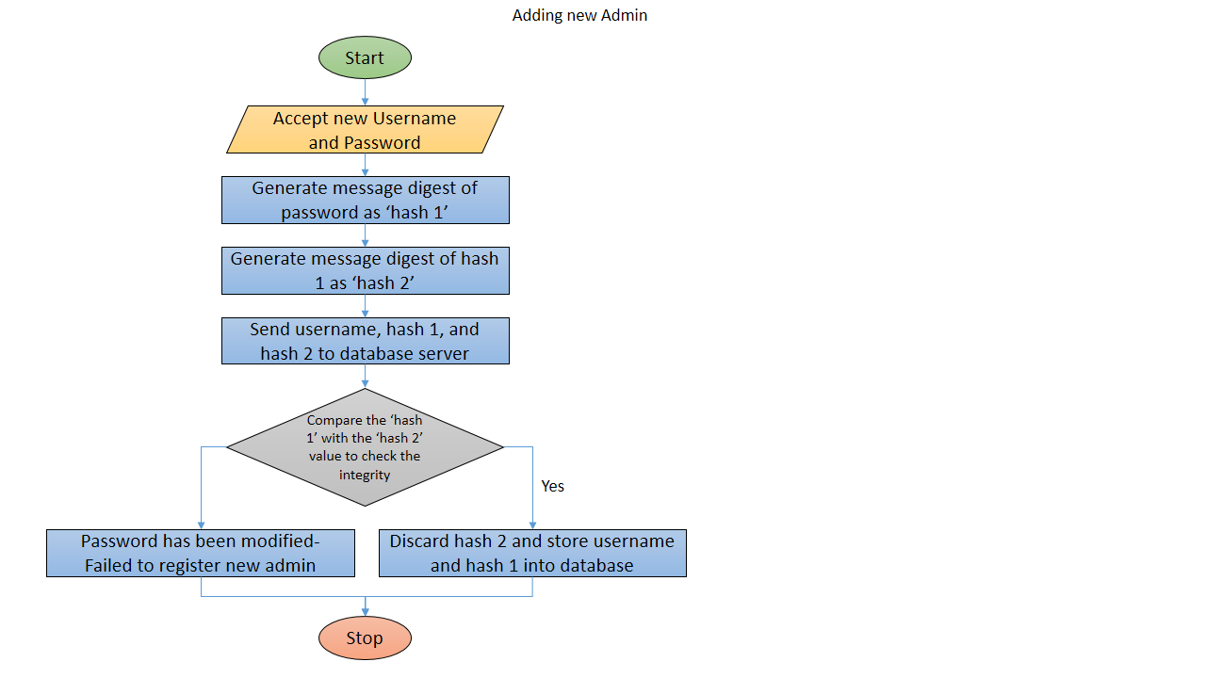

**Fig 6.2: Registering New Admin Password**

**How hash value is generated?**

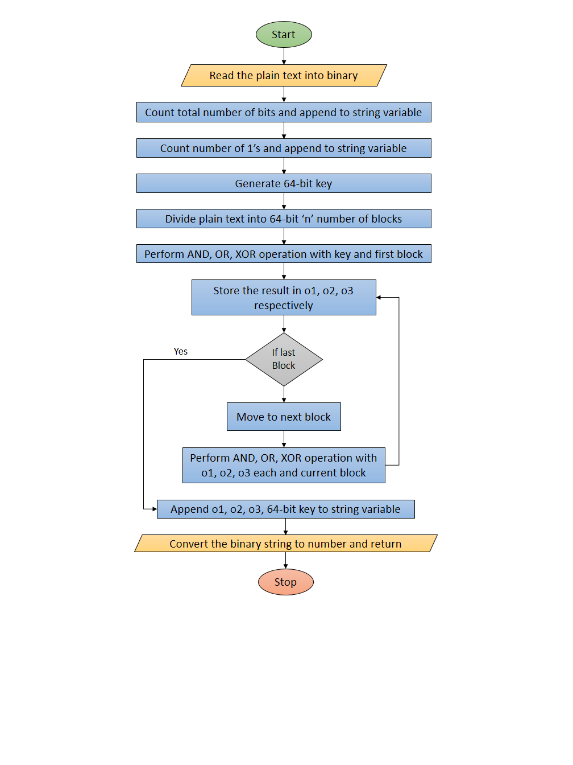

**Fig 6.3: Generating Hash Value**

**How hash value is verified?**

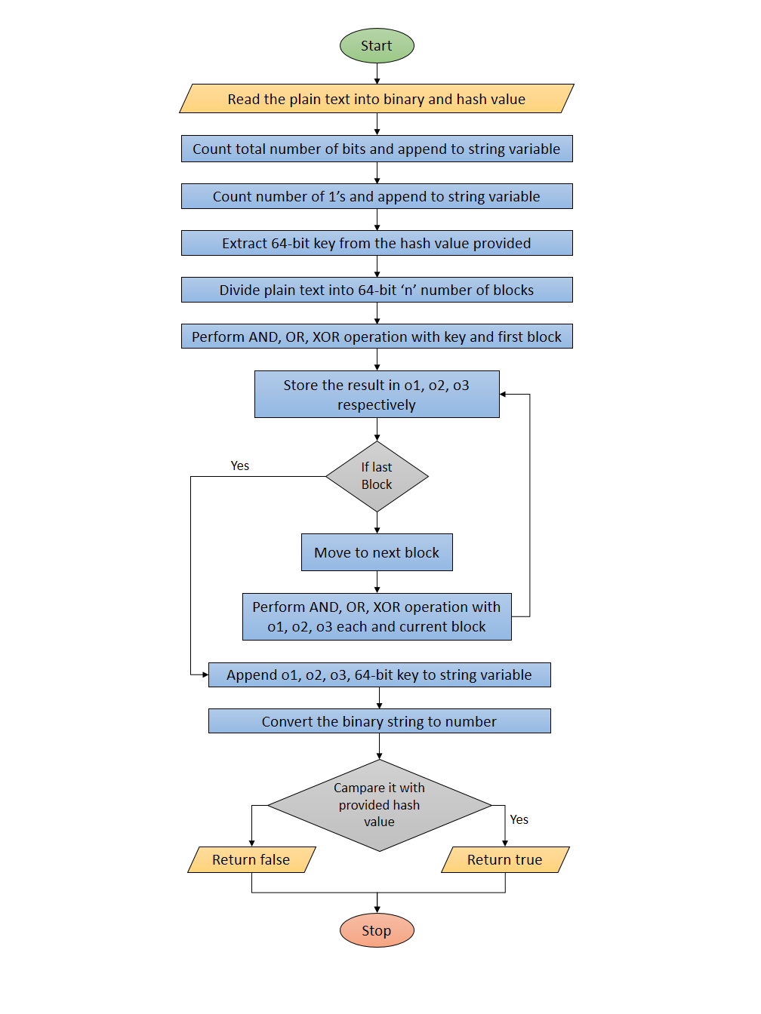

**Fig 6.4: Integrity Checking**

**LOSS LESS COMMUNICATION WITH ARDUINO**

**Problem**

Since there was a need to make biometric system portable, we haveusedarduino to interact with R305 module. And this arduino itself will be communicating with android via serial communication. In serial communication the data is sent one after another in 8-bits or 16-bits of bandwidth. In this process many times there is a problem of data loss or data leakage.

**Solutions**

To overcome this problem we have developed our own communication feedback system which makes sure that the message is delivered successfully and retry if not.

1. First we have defined following unique characters for every messages since sending two or more characters may lead to data loss.

Message definitions are listed below:

|  |  |  |
| --- | --- | --- |
| **Variables** | **Msg Code** | **Message Meaning** |
| **Message from Arduino** | | |
| FINGERPRINT_NOT_FOUND | R | If fingerprint module is not detected |
| READY_FOR_COMMANDS | S | When the finger print module is initialized properly |
| INVALID_INPUT | T | If a command received is not recognised |
| ENTER_FPID_TOENROLL | X | Requesting a fingerprint ID to enroll |
| REMOVE_FINGER | A | Requesting to remove the finger placed on screen |
| PLACE_FINGER | Z | Requesting to place the finger on screen |
| PLACE_SAME_FINGER | B | Requesting to place same finger again |
| ENROLL_SUCCESSFUL | K | Notification message if enrolling is successuful |
| ENTER_FPID_TODELETE | U | Requesting a fingerprint ID to delete |
| FINGERPRINT_DELETED | V | Notification message if fingerprint is deleted |
| COMMUNICATION_ERROR | z | If there is a communication error between fingerprint module and arduino |
| NOT_DELETED | j | Notification message if fingerprint is not deleted |
| ERROR_WRITING_TO_FLASH | s | If new fingerprint is not able to store into memory |
| UNKNOWN_ERROR | W | Something is wrong |
| DATABASE_CLEARED | E | Notification message if database is cleared |
| DATABASE_NOT_CLEARED | F | Notification message if database is not cleared |
| IMAGE_ERROR | x | If 2 fingerprint are not able to compare while enrolling |
| MESSY_IMAGE | w | If the fingerprint scanned is unable to process |
| FINGERPRINTS_NOT_MATCHED | i | If 2 fingerprint doesn’t matched while enrolling |
| NO_MATCH_FOUND | h | If input fingerprint is not present in the database |
| **Message to arduino** | | |
| ENROLL_NEW_FINGERPRINT | e | Request the arduino to enroll new fingerprint |
| DELETE_FINGER_PRINT | d | Request the arduino to delete the fingerprint |
| GET_FINGERPRINT_ID | g | Request the arduino to retrive fingerprint ID when user scans his finger |
| DELETE_ALL_FINGERPRINTS | c | Request the arduino to delete all fingerprints |
| EXIT_CURRENTMODE | b | Request the arduino to exit current mode and enter into main mode |

**Table 6.1: Arduino Communication messages**

1. We have developed a feedback system from arduino to android and vice versa, for example if we want to get the finger print ID from R305 module then following are the steps which takes place
   1. Start
   2. Initialized arduino
   3. Waiting for command
   4. Android keeps sending a message “**Enter into main mode**” unless it gets feedback “**Waiting for command**”
   5. Once the feedback is received android sends another message “**Get finger print ID**” continuously until it gets feedback from arduino “**Place your finger print**”
   6. Now android is waiting for message from arduino and arduino is waiting for user to place his/her finger
   7. Once user places his finger arduino scans it into database and send “**Finger not found**” if the finger is not present or “**<Fingerprint ID>**” if the fingerprint is present.
   8. Android checks if the incoming message is a **MESSAGE** or **FINGERPRINT ID** and reacts on it.
   9. If the incoming message is **ERROR** then appropriate action is taken and if the message is **FINGERPRINT ID** then a successful message is displayed.
   10. Repeat steps ‘f’ to ‘i’ until the user change it.
   11. Stop

**SCREEN SHOTS**

**BIOMETRIC ATTENDANCE ANDROID APPLICATION**

**Login Screen**

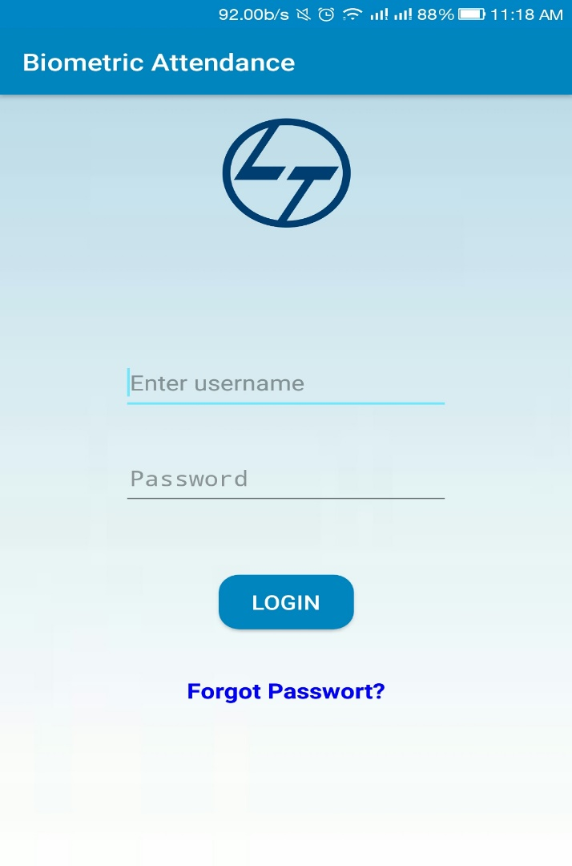

**Fig 6.5 (a): Android App Login Page SS**

**Forgotten Password Recovery via Email OTP**

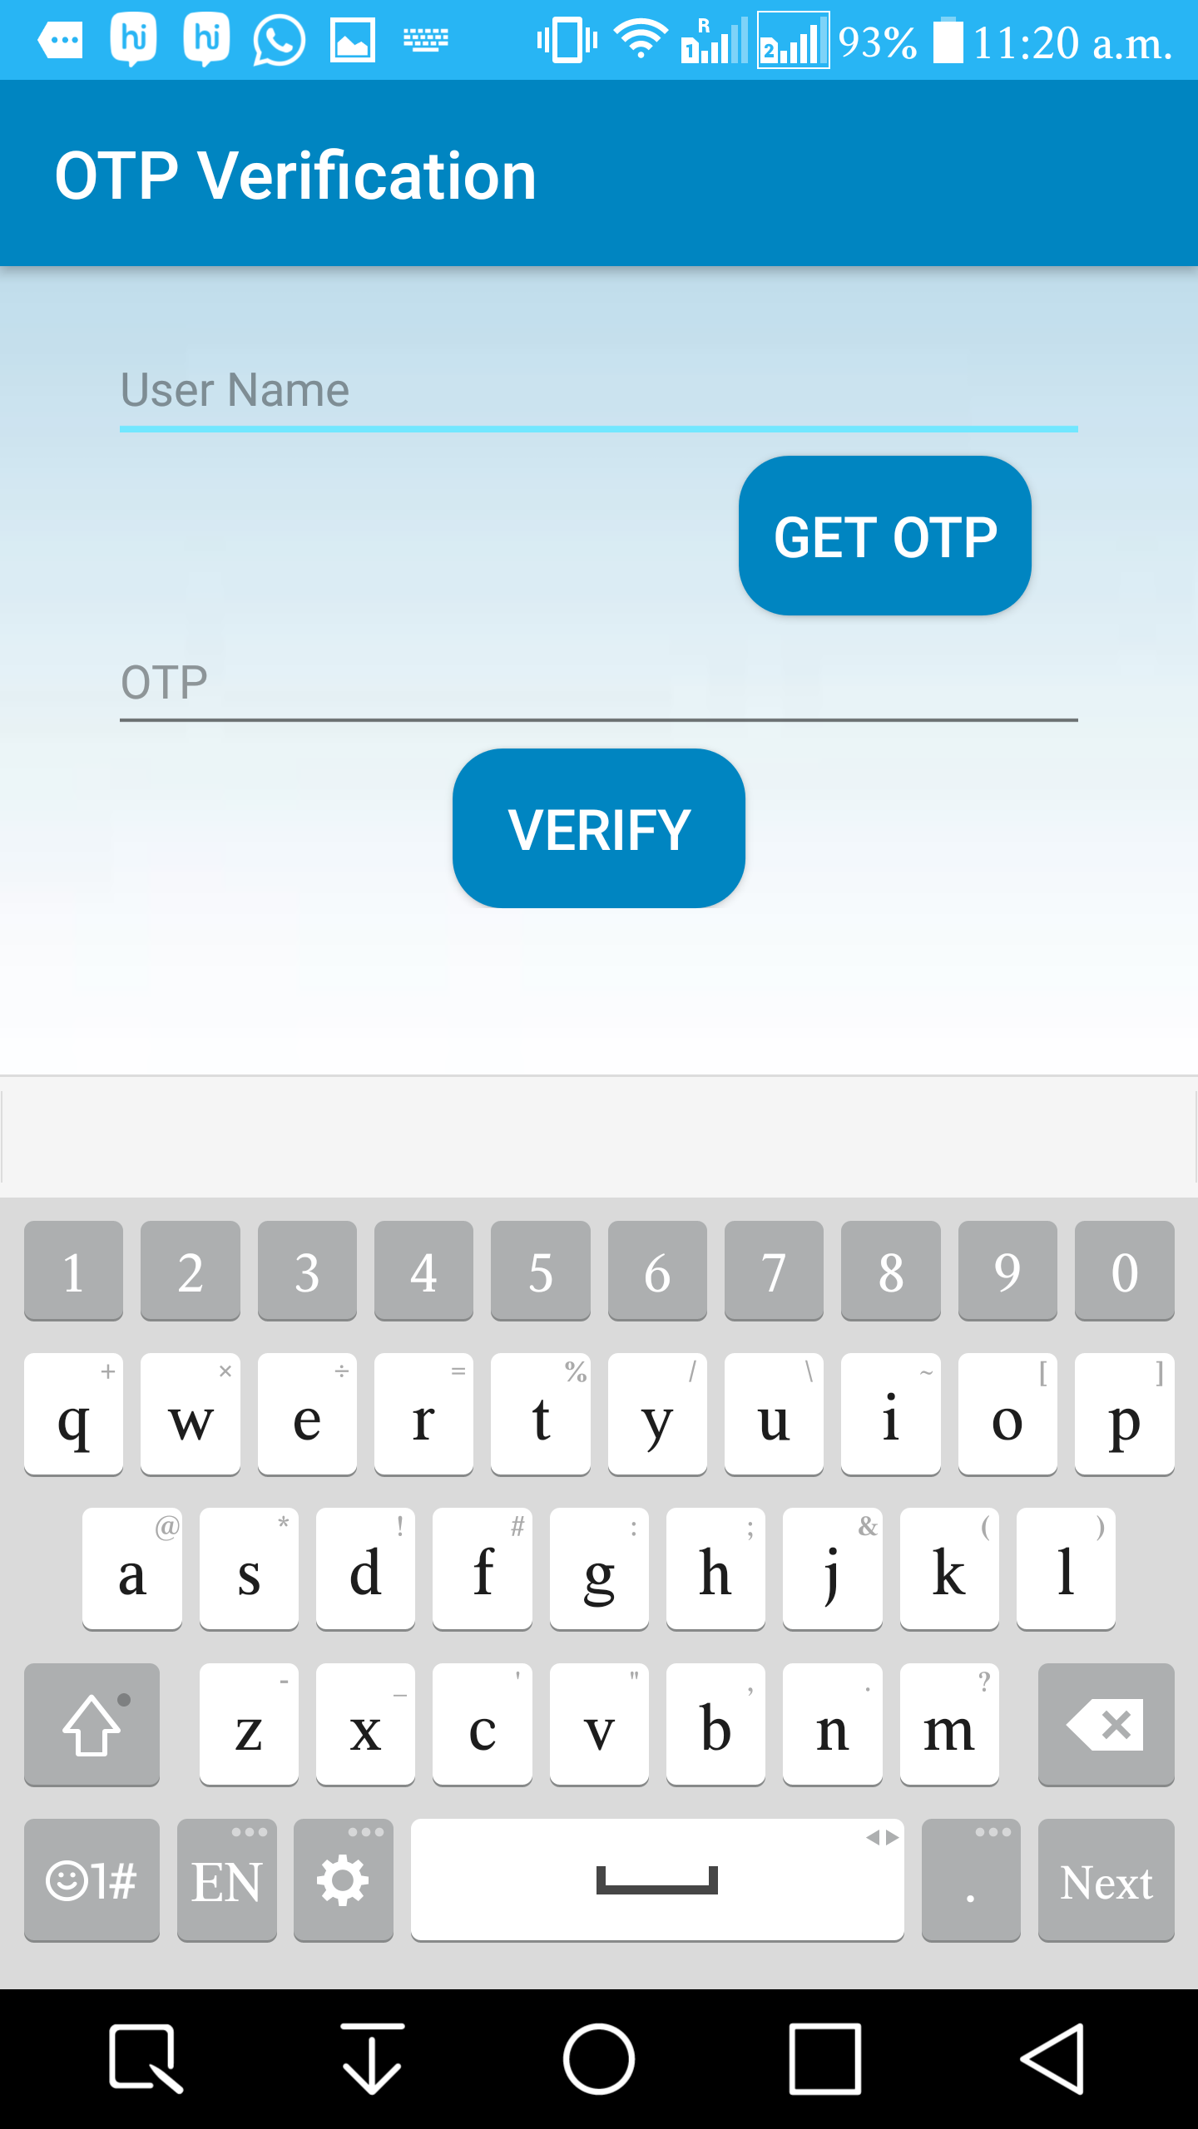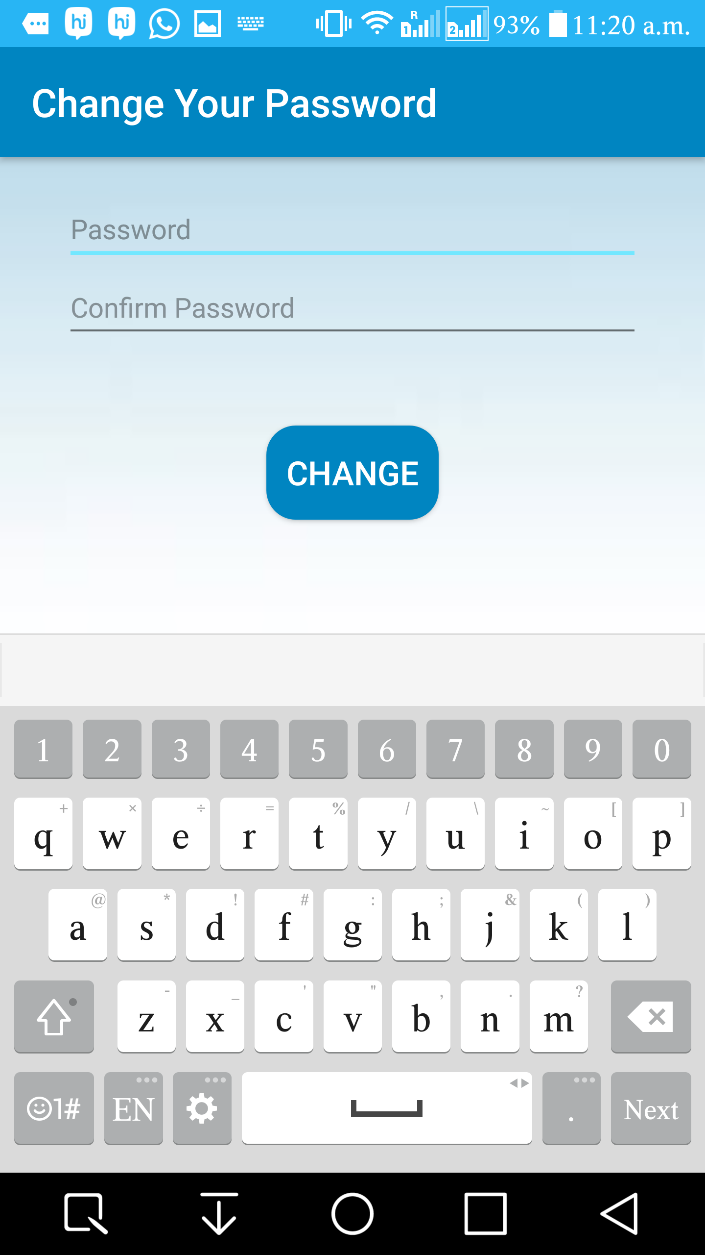

**Fig 6.5 (b): Password Recovery SS**

**Dashboard (Navigation Panel)**

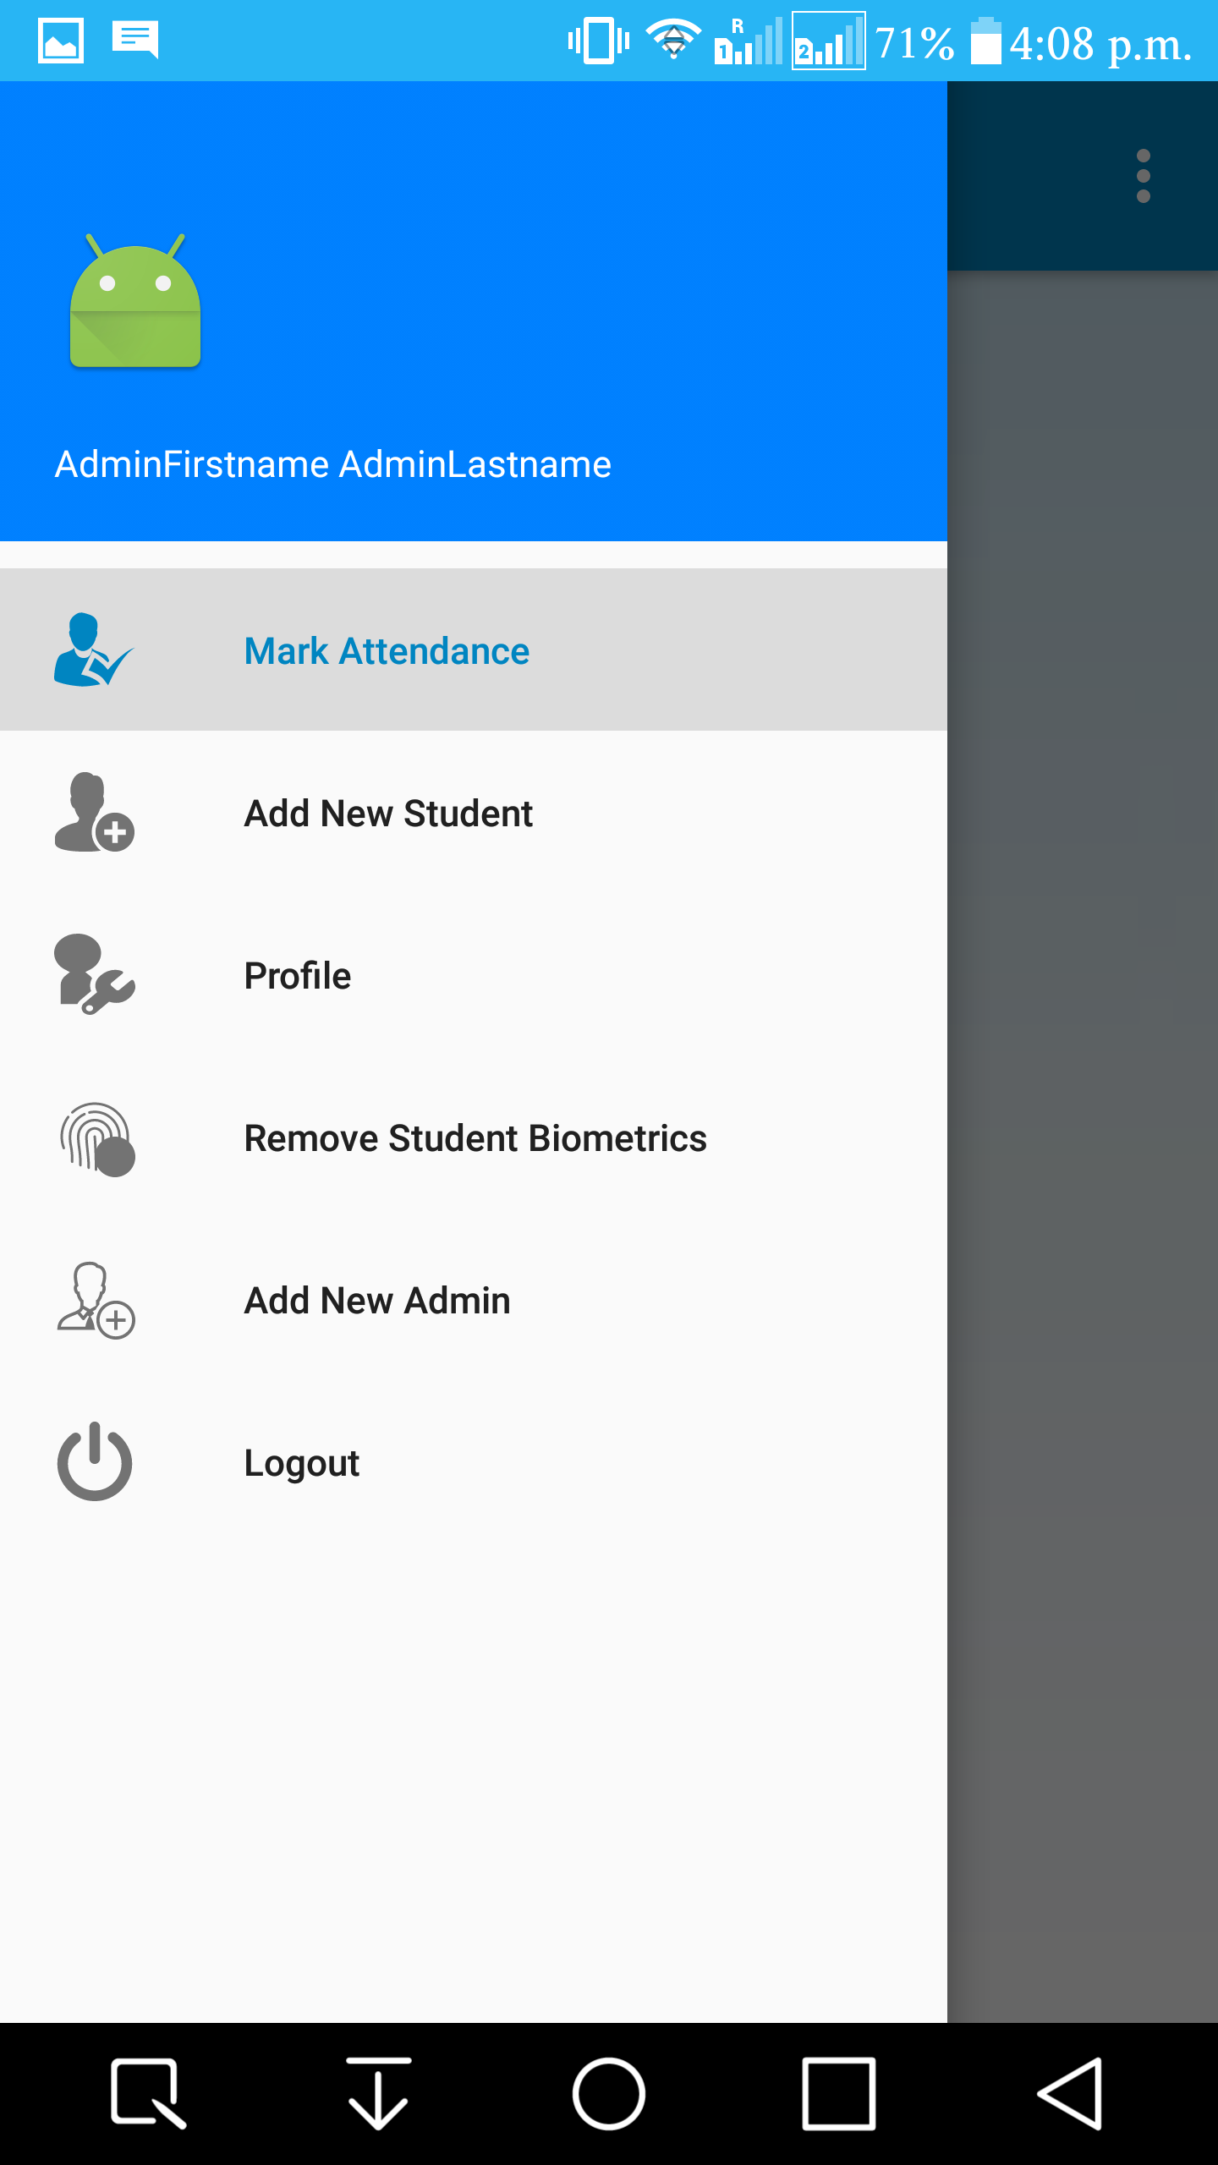

**Fig 6.5 (c): Navigation Panel SS**

**Mark Attendance**

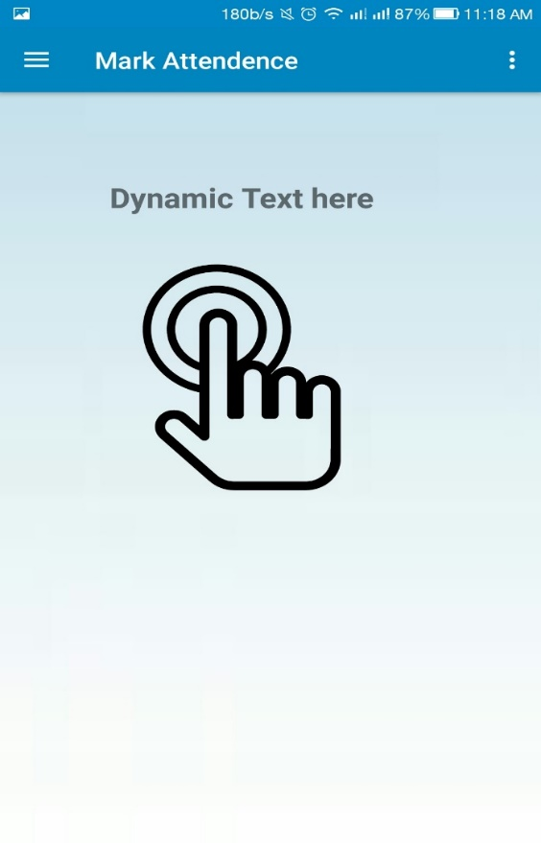

**Fig 6.5 (d): Attendance Marking SS**

**New Student Entry**

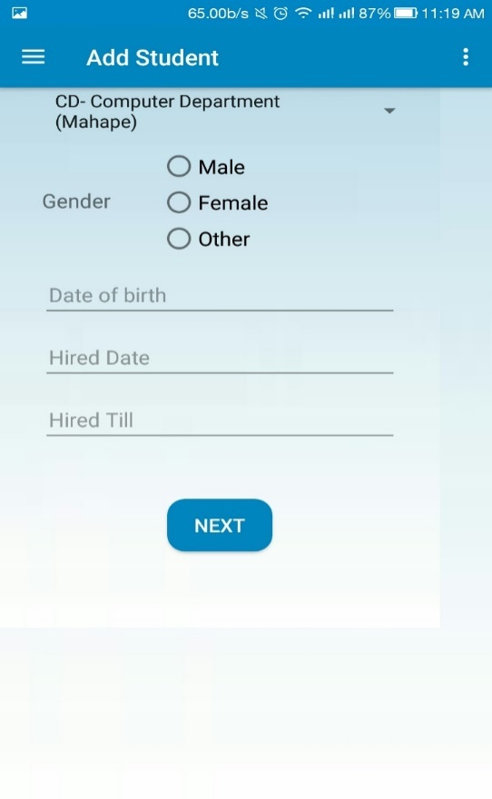 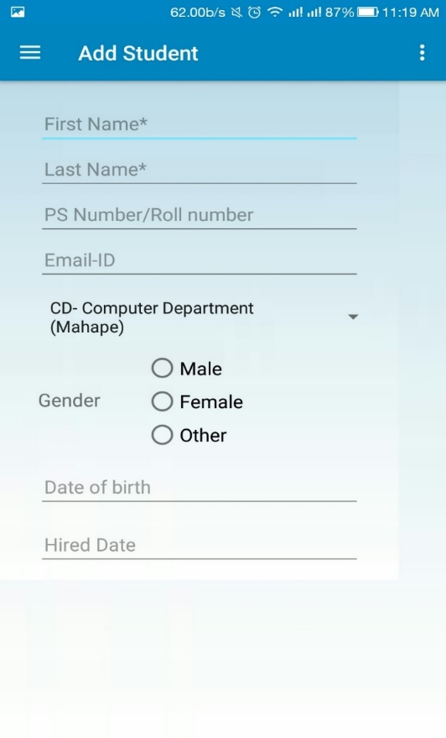

**Fig 6.5 (e): New Student Entry SS**

**Biometric Enrolment**

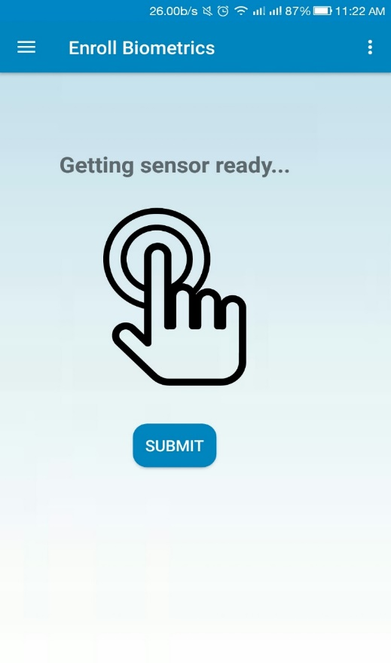

**Fig 6.5 (f): Biometric Enrolment SS**

**Admin Profile**

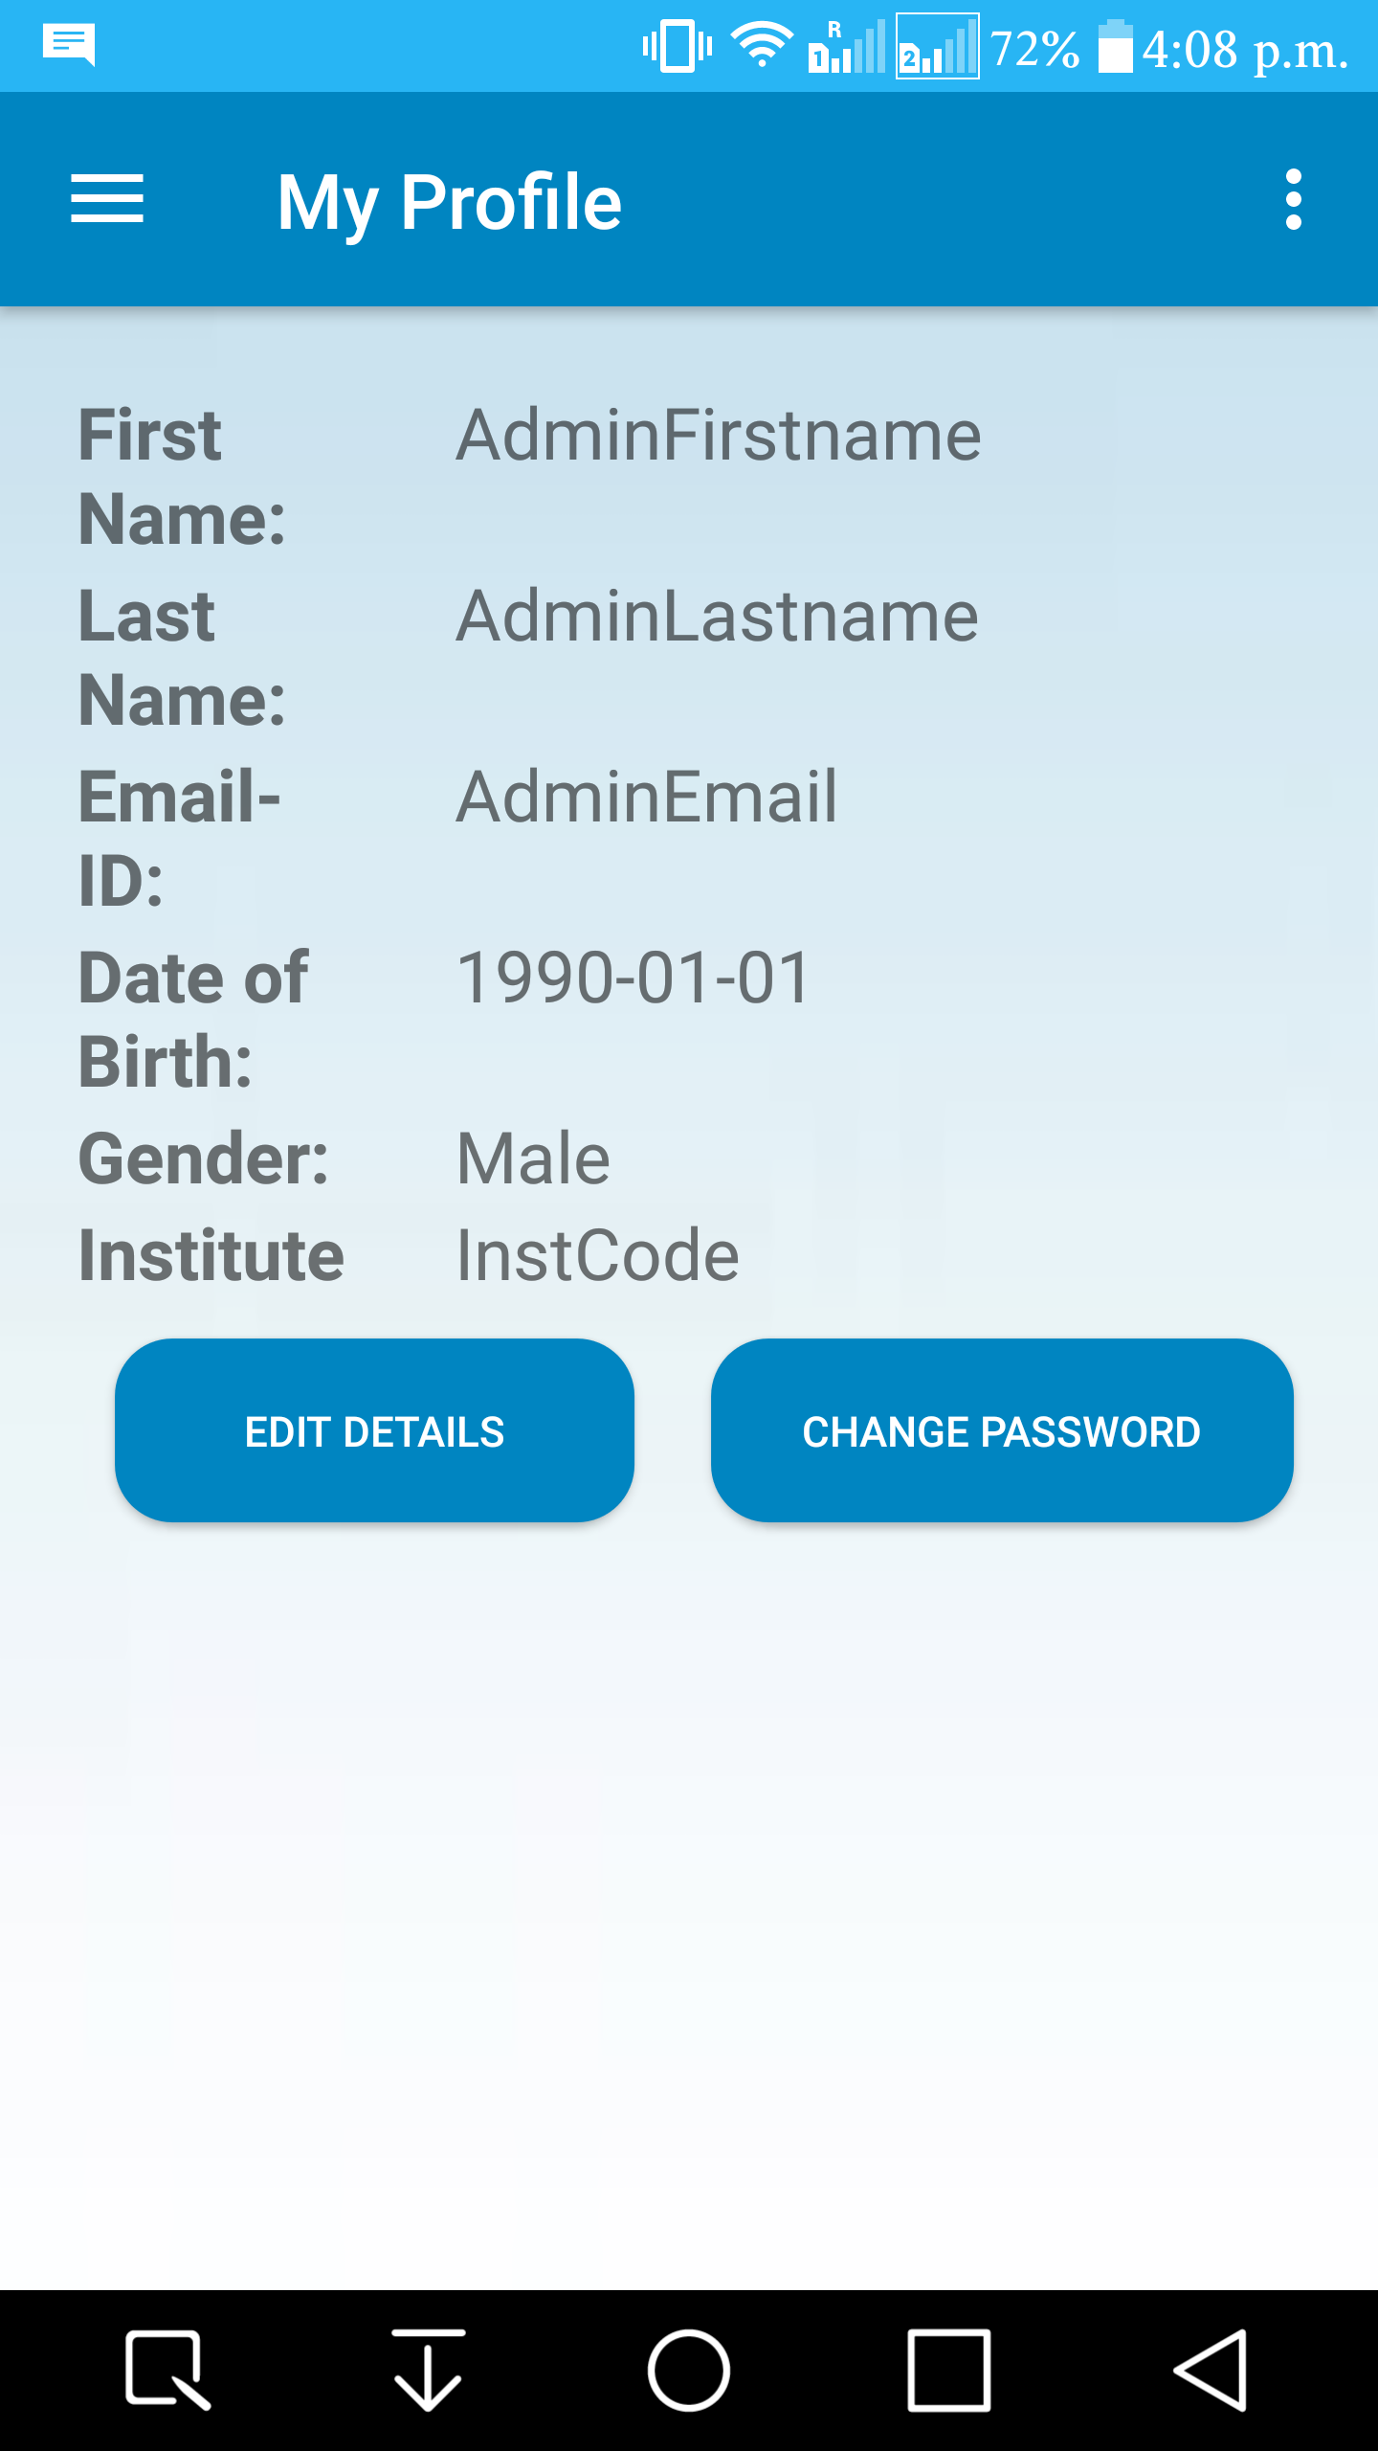

**Fig 6.5 (g): Admin Profile SS**

**Editing Admin Details**

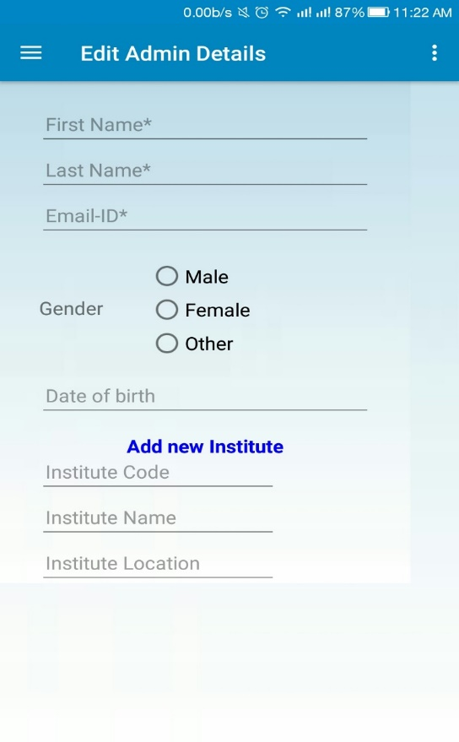 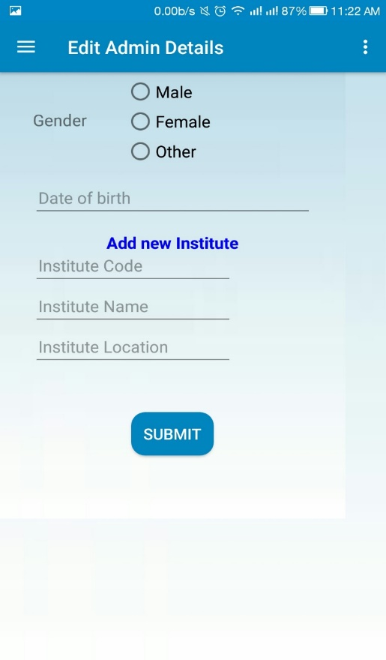

**Fig 6.5 (h): Editing Admin Details SS**

**Admin Password Change**

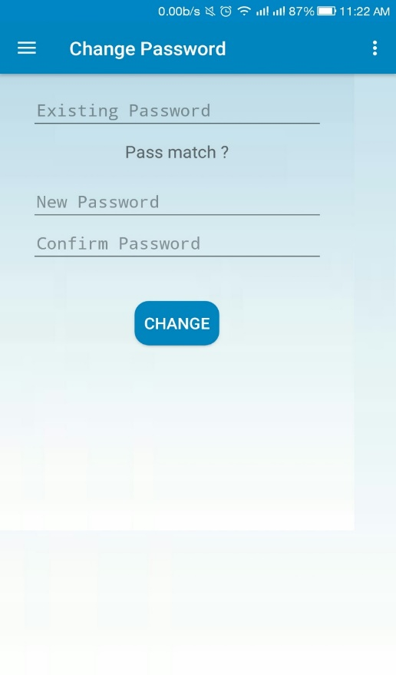

**Fig 6.5 (i): Admin Password Change SS**

**Remove Student Biometrics**

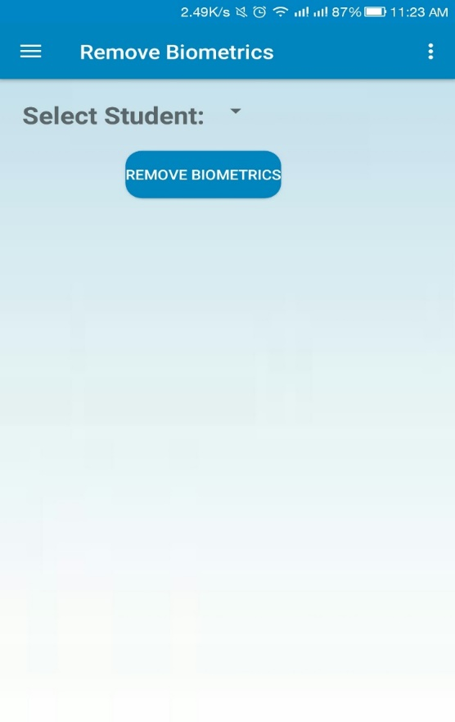 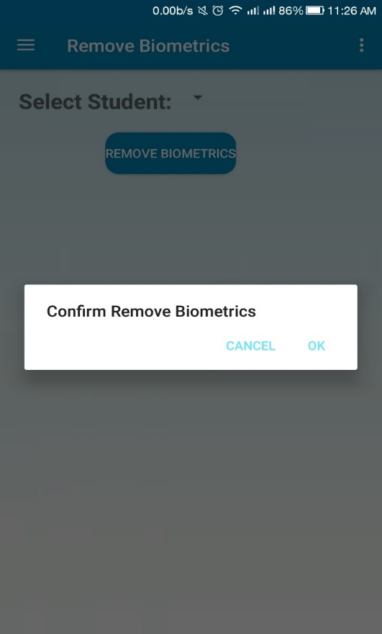

**Fig 6.5 (j): Remove Biometric SS**

**Add new Admin (Credentials)**

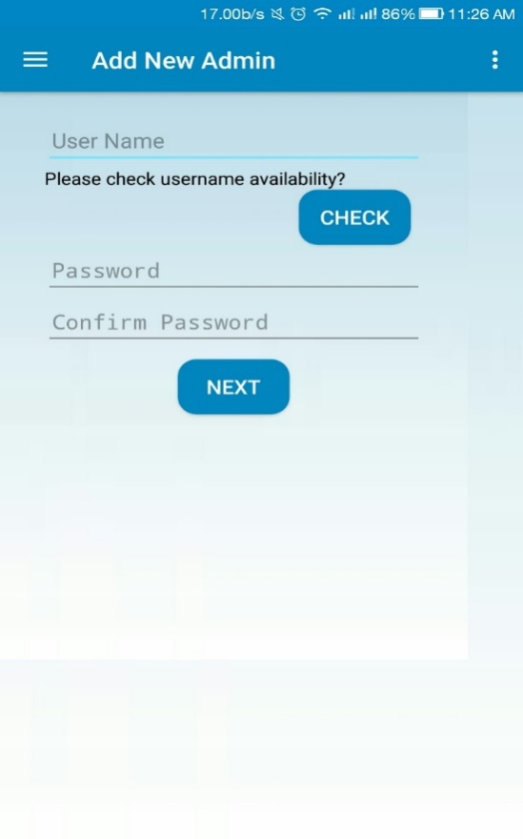

**Fig 6.5 (k): Adding New Admin Credentials SS**

**Add new Admin (Other Details)**

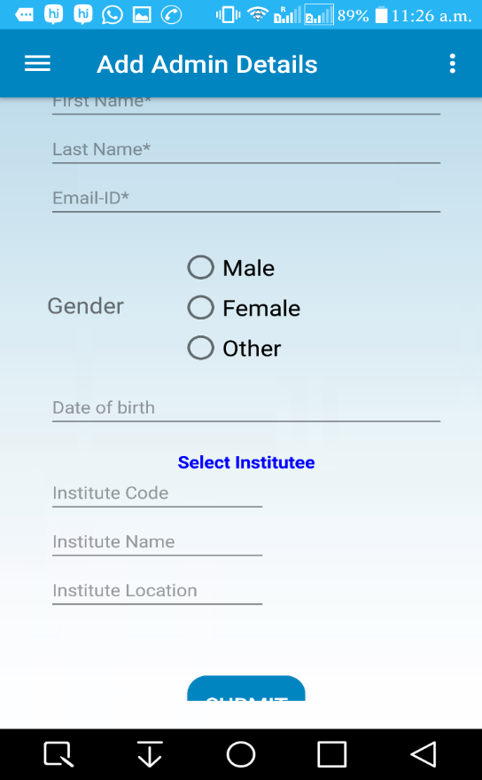 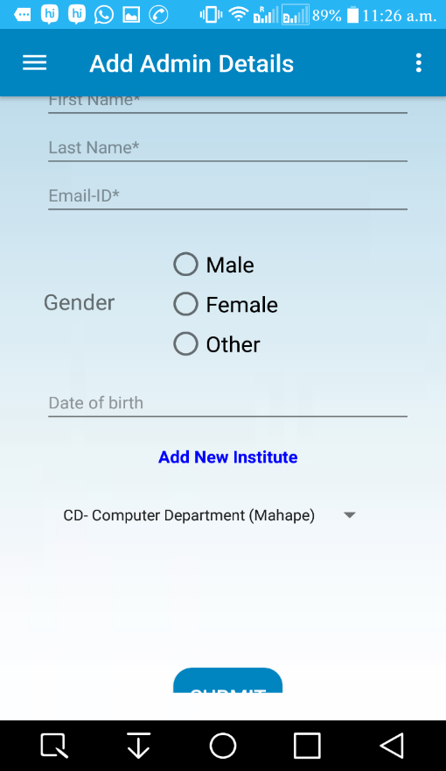

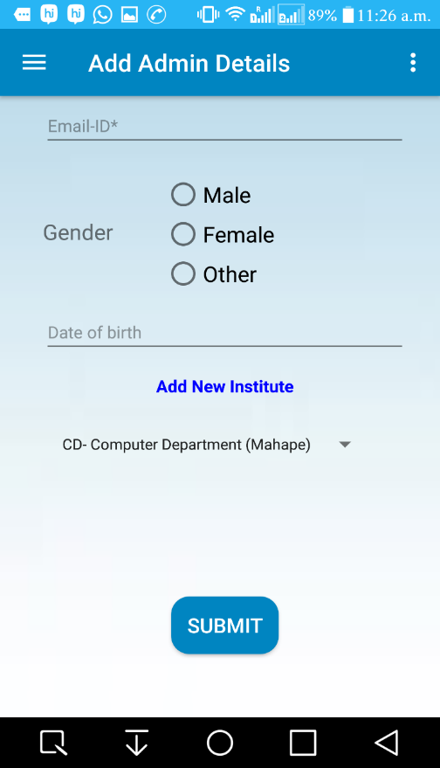

**Fig 6.5 (l): Adding New Admin Details SS**

**BIOMETRIC ATTENDANCE REPORT SCREENSHOTS**

**Login Screen**

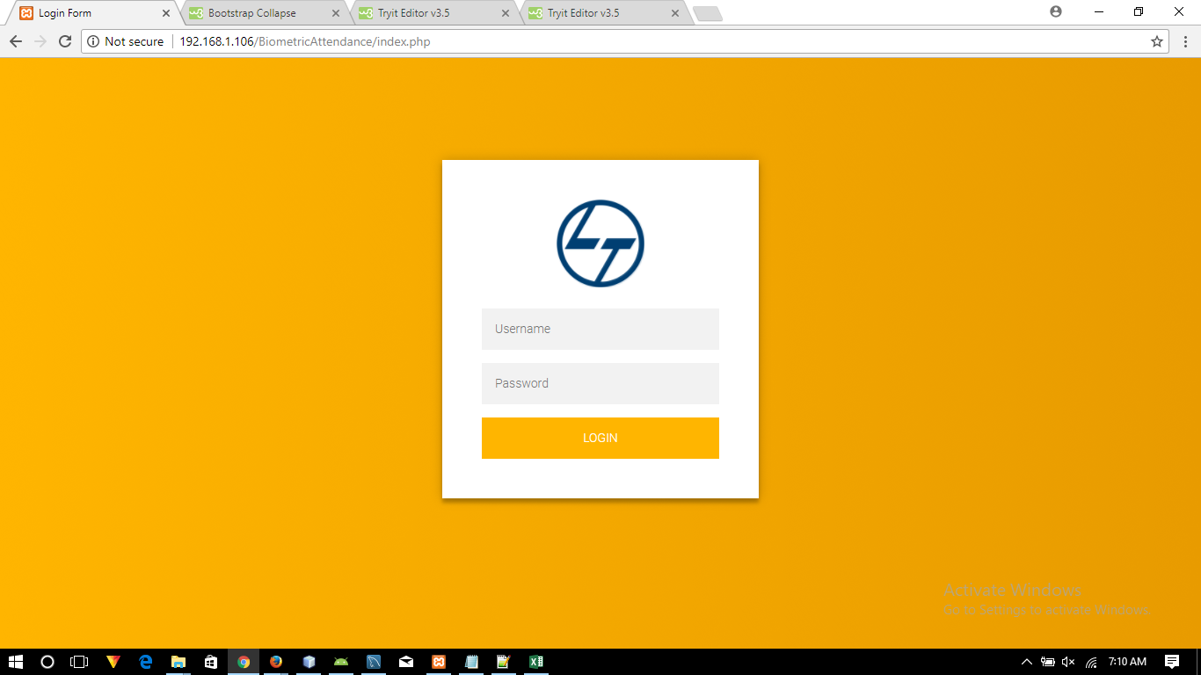

**Fig 6.6 (a): Biometric Attendance Report Login SS**

**Home Page**

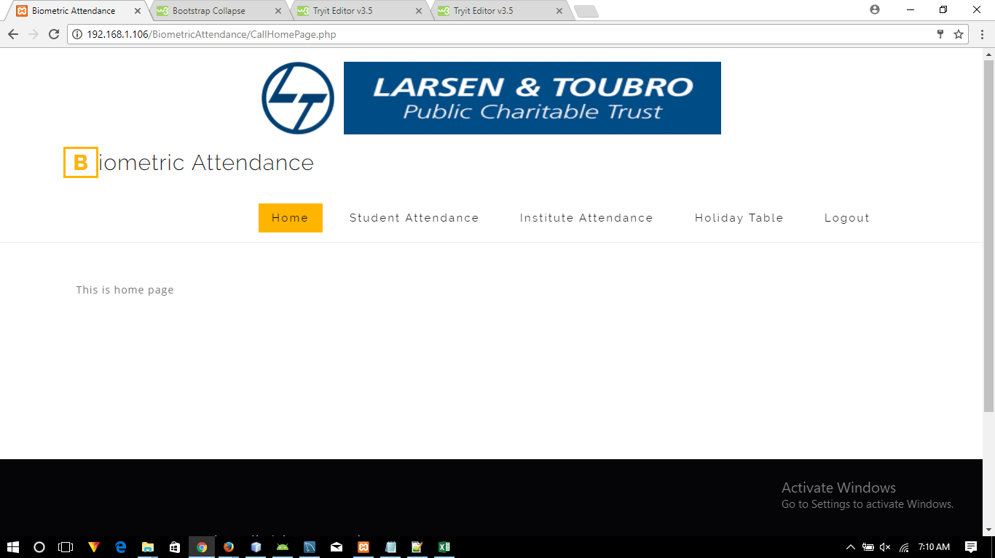

**Fig 6.6 (b): Reporting Home Page SS**

**Student Attendance Report- Selection Criteria**

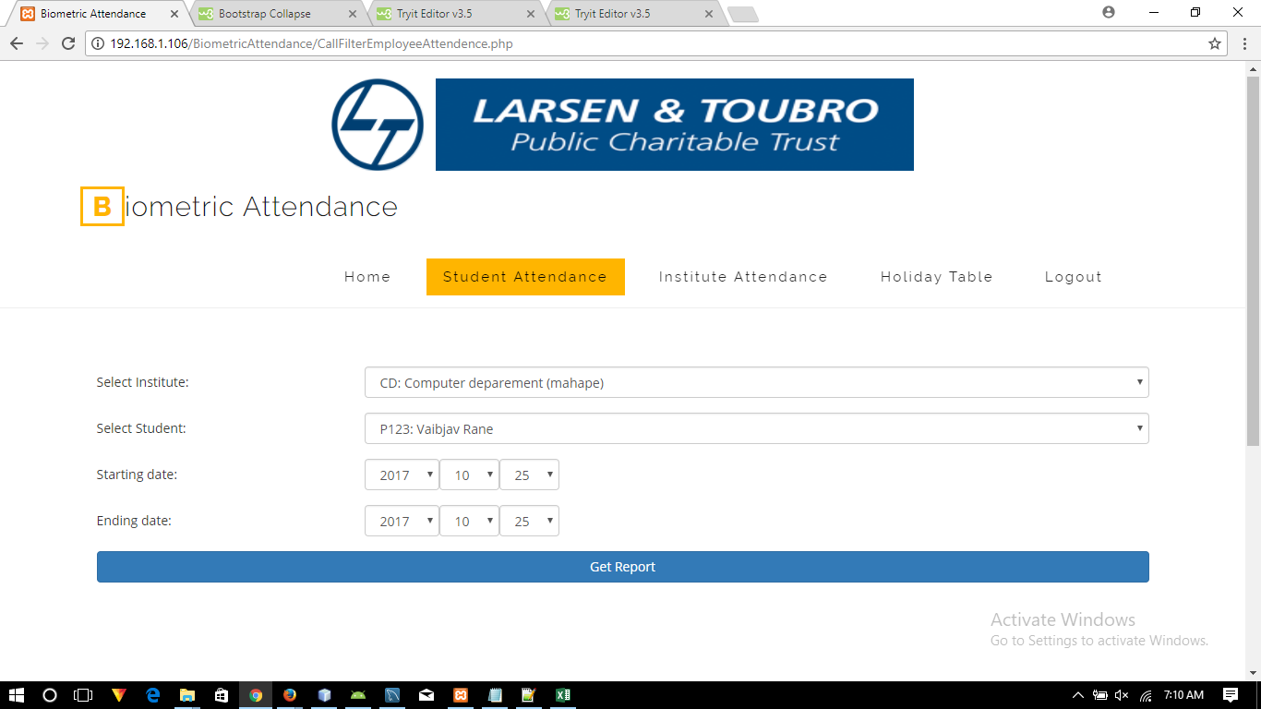

**Fig 6.6 (c): Student Report Selection SS**

**Student Wise Sample Runtime Report**

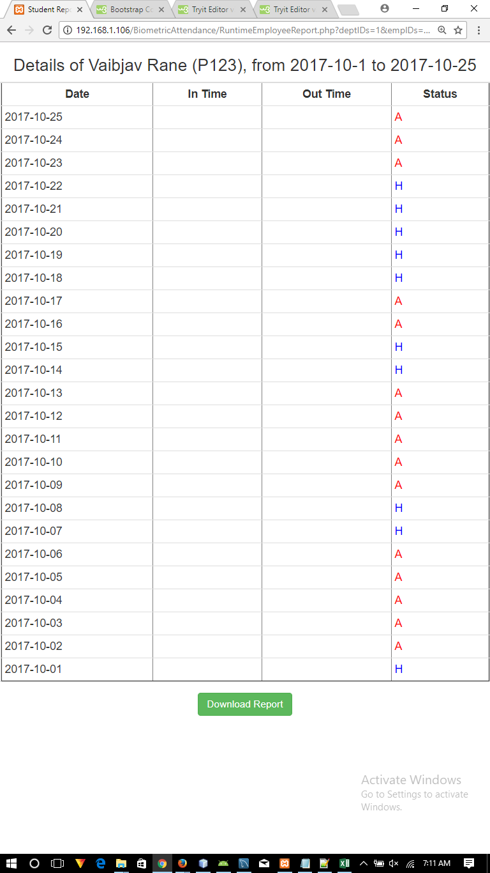

**Fig 6.6 (d): Student Report SS**

**Sample Offline Student Report in Excel**

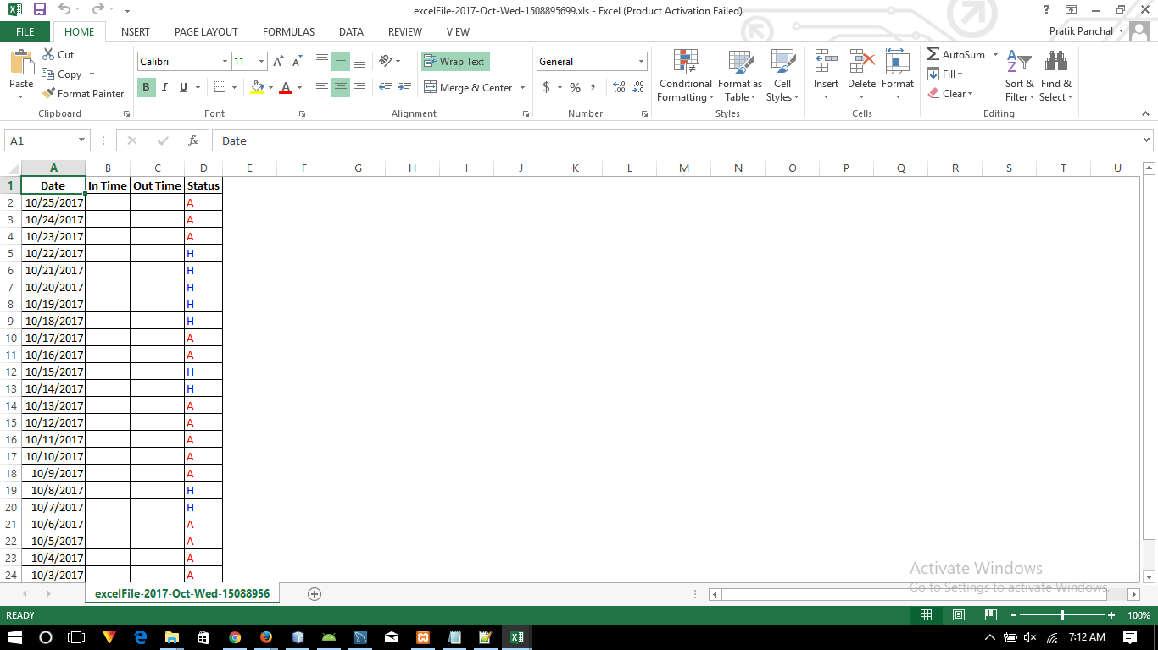

**Fig 6.6 (e): Student Report in Excel SS**

**Institute Attendance Report- Selection Criteria**

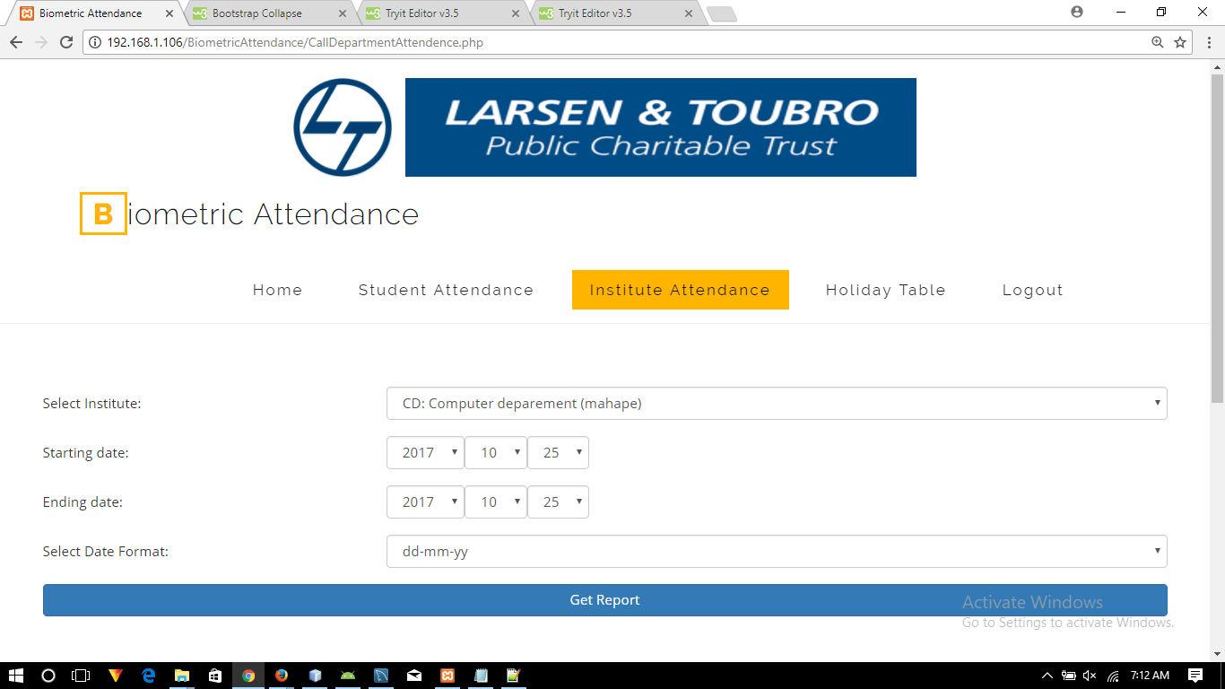

**Fig 6.6 (f): Institute Report Selection SS**

**Institute Wise Attendance Report**

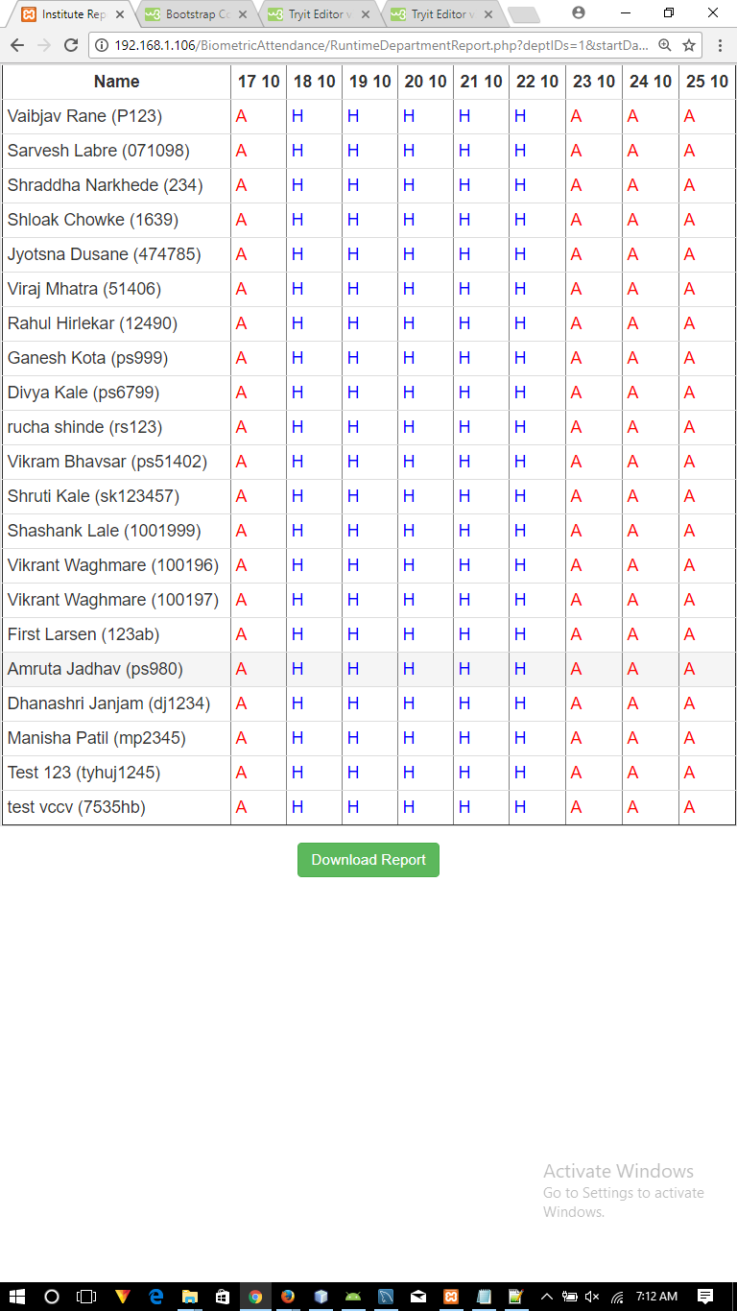

**Fig 6.6 (g): Institute Report SS**

**Sample Offline Institute Report in Excel**

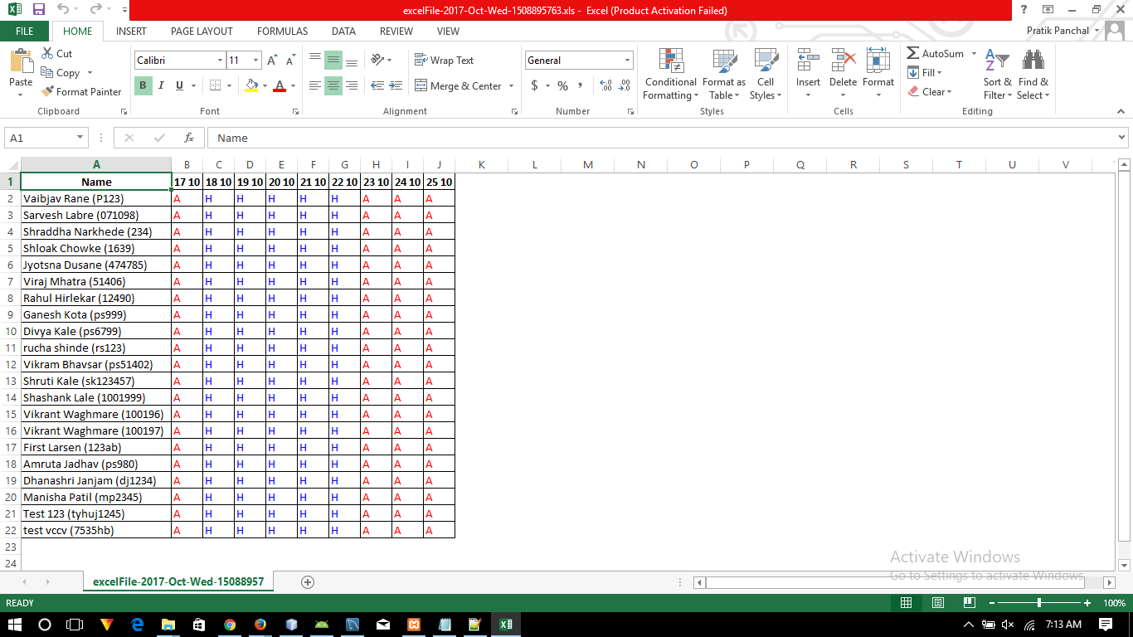

**Fig 6.6 (h): Institute Report in Excel SS**

**Holiday master entry**

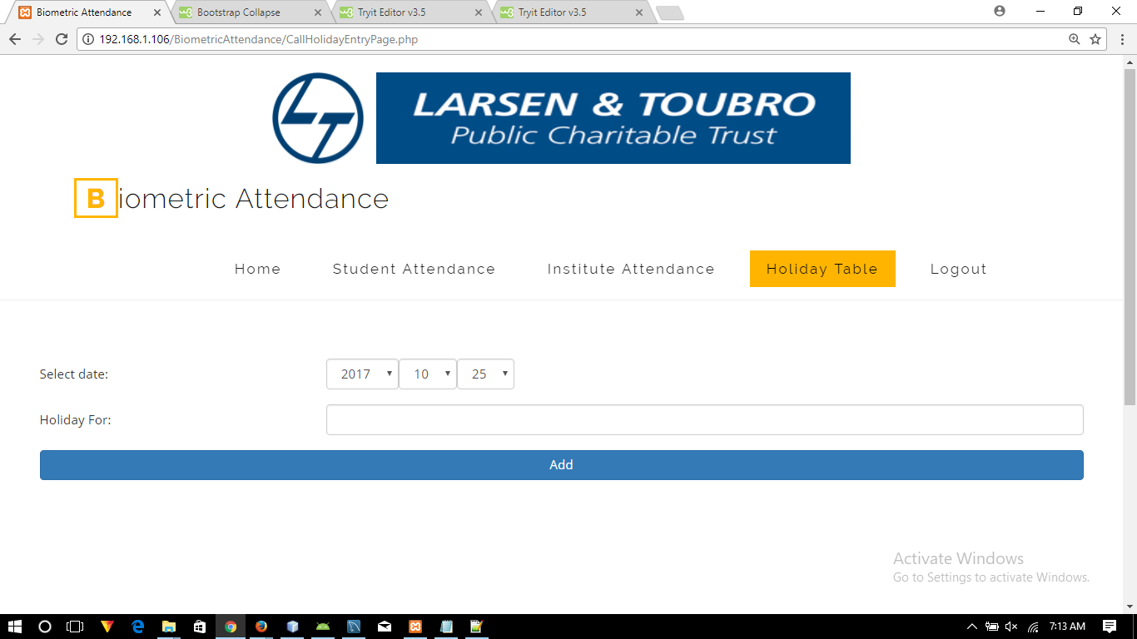

**Fig 6.6 (i): Holiday Master SS**

**Chapter 7**

**CONLUSION**

**CONCLUSION**

The development of any organization depends highly on the effective attendance management of its employees/students. This will provide the necessary security and skills that is required for the progress of the organization.

Different techniques are been applied for managing the attendance of employees/students but they are not so reliable. Employees/Students come to work/school/colleges late and leave early, some sign attendance for others and some does not come still has good attendance record.

These problems are solved by using biometric authentication technology using fingerprint since a person’s biometric data is undeniably connected to its owner, is non-transferable and unique for every individual. The system has been integrated using fingerprint biometric technology that will efficiently enable organizations manage the attendance of their employees/students which will greatly improve the progress of organizations.

It prevents time-consuming processes. Employee/Student attendance system provides the administrator with easy access. This will improve the net productivity of organization. This system ensures security of employee’s/student’s records.

Therefore the objectives stated in “Chapter 3” has been successfully accomplished, that is our project

* Provides an efficient and effective attendance management system.
* Maintains perfect attendance into centralized database
* Has internet based communication
* Avoid manipulation of attendance
* Ensures that cheats are impossible
* Itself is a portable device
* Allows to view daily, monthly and yearly attendance reports of all locations.
* Allows to take attendance from various locations using Biometric Fingerprint Device.

**Chapter 8**

**FUTURE SCOPE**

**FUTURE SCOPE**

Improvement is something which has no end. The more you improve the better your product will be. Similarly there are lot of things which can be done in our project so that it improves the efficiency, reliability and performance of the system.

Some of the modifications are listed below:

* The proposed system can be improved using multimodal (multiple biometrics e.g. face recognition, iris, signature, voice, etc.) biometric technologies.
* Memory limitation can be eliminated by storing actual image in the database.
* Wireless independent fingerprint module can be made.

**Chapter 9**

**LIMITATIONS**

**LIMITATIONS**

* The fingerprint of employee is stored inside fingerprint module itself.
* The fingerprint module can store maximum 162 fingerprints.
* If the employee/student has abnormal fingerprint, the system may not authenticate correctly.
* Wired connection with android device.
* One fingerprint module can be used for one institute only.

**Chapter 10**

**REFERENCES**

**REFERENCES**

* <https://learn.adafruit.com>
* <https://www.arduino.cc/>
* <https://developer.android.com>
* <https://www.apachefriends.org>
* <https://www.mysql.com/>
* <http://www.oracle.com/>
* <https://github.com>
* <https://stackoverflow.com/>
* <https://www.tutorialspoint.com/>
* <https://www.w3schools.com/>